The Reflector

Shippensburg University’s
Journal of the Arts

2026

The Reflector



The Reflector, founded in 1957, is the annual Undergraduate Arts Journal financed by the Student Government Association of Shippensburg University. We accept works of fiction, nonfiction, poetry, interviews, and artwork year-round. Works are considered for publication based on a blind submission policy. Submissions are accepted electronically at reflect@ship.edu. All writers/artists retain rights to their work.

For questions regarding our submission policy, contact:
reflect@ship.edu. Visit The Reflector on Facebook (The Reflector, Journal of the Arts) or Instagram (@shippensburg.reflector). The Reflector office is located in the old section of Shippensburg University, in the Creative Writing Wing of Horton Hall, Room 301.

The Reflector. Issue 2026
Cover Art: Yellow
Cover Design: Katelyn Mader
Book Layout and Design: Katelyn Mader and Emily Brewer
Cover Stock: Silk Cover 100#
Paper Stock: Finch Bright White Smooth Vellum, 70 lb.
Text set in Cambria
Printed by Mercersburg, Printing, Mercersburg, PA.
Staff
Executive Board
Editor-In-Chief Katelyn Mader

Associate Editor Emily Brewer

Public Relations Chair Tomi May

Treasurer Annikka Stangil

Genre Editors

Prose Morgyn Thomas
Shawn Mcguigan

Poetry Reed Vollrath
Alex Heckman

Art
Bailey Riley– Chatfield

Gretchen Lambie

Committee Members

Prose
Sarah Burrows
Kylie Saar
Lindsay Smith
Annika Stangil
Poetry
Paige Becker
Alcinda Burchill
Elizabeth Engle

Art Ava Hawes
Elias Johnson
Brooke Miller
Emily Shah

Faculty Advisor Dr. Nicole Santalucia

Contents
Poetry
Ava McWilliams
The Change of the Seasons 16
The Moon Thinks She Created Her
Own Light 39
Beauty is in the Eye of the
Beholder 31

Daniel Wintersgil
trees 26
the grapes’ rainbath 61
I, hedonist 153

Dale Crowley
The Flavor of Solitude 29

Jenna Tecchio
Moon Poem 37
Breaking the Cycle 194
A Man’s Best Friend 209

Kacey Sollenberger
My Body/ A Book 56

Lauren Pool
Willow in the Spring 59
Keep Digging 213

Alyssa Sheriff
Palette of Life 64
The Perfect Pumpkin 17
The Box Fan Hums 103

Kleio Mae
I Fear 66
How to find your special
someone 131

Jenny Russell
Animal 133

Rebekah Garrido
Little Girl 85

Kaylee Will
Well Loved 87
I would like to 112

Emmett O’Bell
The Lamp Dream 100
An Allegory of Catholic Faith 114
How a Tiger Brushes Her Teeth 150

Jean Stitchfield
American Television 109
Eggs 141

Katie Waite
Vampire Argument 41
Femina 144

Eloise Brewsy
Juice from an orange 158
Eggs in a Basket 203

Reed Vollrath
Sowing Dreams 136
Bloodletting 160

Ava Hawes
What do you Fear? 179
My Time in New York 156

Ashley Toms
I Hear the Birds 162
Mr. Benson’s Latex Skin 181
What is the Opposite of Speed 196

Alex Heckman
My Friend Death 192

Anonymous
Butts IX 207

Carmela Caracotche
I Don’t Know a Thing 187
New York in December 205
This is Not a Poem 215

Kylie Saar
His Harvest 68
Rotten Fruit 90

Benjamin Zacharias
I’ve Been to Haunted Houses 105

Alcinda Burchill
The Colors of my Heart 147

Prose
Kleio Mae
Pursuit of Happiness 18

Jean Stitchfield
Fish 33

Eloise Brewsy
Shaping Margot 43

Hailee Rauch
Sunset 62
The Days After It 69

Alex Heckman
Things Left Behind 92 Secret of the Mountains 115

Kacey Sollenberger
Rock 106 Gallows 148

Jenny Russell
The Park is so Cold After Dark 137

Benjamin Zacharias
The Boar 157

Reese Golden
A Forge of Corpses and
Monsters 164

Shawn McGuigan
Comes to Shove 188

Hannah Campbell
The History of the End of the
World 197

Katie Waite
Lines 210

Art
Elias Johnson
Passing Through Natures
Embrace 28
A Moment in the Passage of Time 58
Anxiety 180

Anna Eastman
The Perfect Autumn Day: Hidden Bridge in the Woods 38
In Utero: 2 86
The Perfect Autumn Day: Bug Crawling
on a Miniature Daisy 143

Noah Guillaume
Bee Mine 65
On My Way 113
Untitled 161

Rose Emenheiser
Goblin Party 60
Self Portrait 146
Serenity 155

Elizabeth Lonkart
Venice 102
Cat Eye 152
Bar 208

Hannah Campbell
This is Fine, probably: A Tale of An Optimistic Navigator 111
Clawing at thin air 159

Gretchen Steel
Untitled 67
Untitled 132
Untitled 135

Jenny Russell
Have you seen --- 193

Eleanor George
Exit Routes 204

Madison Sharp
Closing Time 195
Blind Date 214

Lauren Pool
Ghost Dancer 186

Mallory Reynolds
Alien: Romulus 40
The Best Stardew Bachelor 89
The Ballad of a Midwestern
Gothic 104

A Letter from the Editor

Dear Reader,
Where to begin? After spending the last 3 years a part of this wonderful journal, it feels surreal to be writing this letter to you all. The Reflector has been a staple of Shippensburg University since 1957, an incredible 69 years, and to be a part of that legacy is an incredible feeling that I hope everyone who has played some part in this journal is experiencing. But before I get too sentimental, a round of thanks to everyone who has helped bring the 2025-2026 Reflector to life.
Thank you to Emily Brewer, our Associate Editor, Tomi May, our PR Chair, and Annikka Stangil, our Treasurer. These three have truly kept me sane through all the successes and setbacks of creating this journal, and I don’t know what I would have done without you three by my side, so thank you.
Thank you to our Genre Editors: Alex Heckman, Gretchen Lambie, Shawn McGuigan, Bailey Riley-Chatfield, Morgyn Thomas, and Reed Vollrath. You all have done incredible work to prep this journal, and I wish you all the best of luck moving forward wherever life brings you.
Thank you to Dr. Nicole Santalucia, our advisor for The Reflector. Your support throughout the school year has been nothing less than incredible, and words can’t describe how grateful we all are for your presence.
Thank you to Dawn Heefner and the Mercersburg Printing Company; being able to hold a Reflector book in our hands and see our amazing work would not be possible without them.
And most important of all, thank you to every student who has submitted, who has ranked, and who has supported us at our events and book launches. All of you are the reason we are able to keep this tradition alive, and so you receive the biggest thank you of all.
You know, at first I put off writing this letter. I was scared of the finality of it because it meant I was preparing to leave this community that has supported and shaped me for the past 3 years. I came to the realization though that I shouldn’t be scared of leaving, but that I should be excited for the new beginnings coming my way. I’ve met some of the most amazing people through this journal, and I believe it has curated me into the best version of myself to tackle the future. These relationships and these opportunities are going to follow me wherever life takes me, and I am truly grateful for the profound effect that this place and these people have had on me.
I’m going to wrap up before I get too sappy (if you see a tear stain, no you don’t), but it is my sincerest desire that everyone who reads this journal finds a semblance of home, of community in it. I know I did.
Thank you all again, and I hope you enjoy!

With Love,
Katelyn Mader

/or

The Changing of the Seasons

I am the sound of crunching leaves beneath your feet
and the colors of a wildfire.
I am the smell of damp dryness
and the taste of bitter sweetness.
I am the death of brightness
and the hope of darkness.
I am warmth amid the cold burning brush.
I heat you from the inside out with nostalgia
reminding you of what was and what will come.
I bring my destruction and leave you with nothing
to give you a chance to start again.

Ava McWilliams

The Perfect Pumpkin

Cutting open my orange head,
I scrape at the inside.
First with a spatula,
but eventually giving up and digging in with fingers.
Gooey seeds slide in my hands,
as intestines plaster hair to arm,
and orange strings beneath my fingernails.
I carve
eyes, mouth, nose,
and place a candle inside.
Rolling onto the doorstep as neighborhood kids pass
quiet “oohs” and “ahhs” echo
Among roasted pumpkin seeds,
And faint expectations of candy.
Until a bat,
Upset that I have no sweetness left to give,
removes me from my foundation
And drops me in the street.
Remaining guts splatter on blacktop
Beneath trick-or-treating feet.
Until I molt and mold on passing car tires.
My sweetness moving with only them,
But not me.
Alyssa Sheriff
Pursuit of Happiness
“Remind me why I decided to play basketball in college?”
“Because you love the sport?”
“With these 5AM’s that’s debatable.”
I ended up dropping the shoe I was trying to put on, my hand whipping up too late to cover the snort. Our resident trash-talker, Casper, whirled around with a grin on his face.
“You agree with me, right Marcus?”
“Leave him alone Mr. Friendly Ghost, with how hard we all partied this weekend I’m shocked he’s upright. You, on the other hand, need some reminders of why you enjoy basketball.” Carlos, our captain, explained while he grabbed Casper’s shoulder and dragged him off to practice before Coach showed up. I caught the little smirk Carlos was wearing as he ignored the offended look on Casper’s face.
Another small laugh bubbled out of me before I reached for the black and red shoe that I dropped on the glossy gym floor. I’m shocked he hasn’t gotten used to the nickname, he’s only had it for the past three years. I went to grab the red practice jersey in the bag when I heard my name to the right of me.
“Yo, Marcus! How are you not dead buddy?” One of my fellow juniors, Tommy, dropped his duffle bag beside mine and he attempted to ruffle the blond curls on my head.
I swatted his hand away with a grin, “That’s because some of us can actually hold our own, and do you really think practice is the best time to discuss this?”
Tommy let out a bark of a laugh, taking off the white windbreaker we all have that says University of Houston Men’s Basketball. He replied, “I get you worry all the damn time, but Coach isn’t even here yet! We’re fine man.”
I rolled my eyes and grabbed the windbreaker he just took off, then proceeded to whip his shoulder. “At least my worrying keeps me from puking my guts out in some random frat, and how the hell can you wear this? I get that Halloween was last weekend, but it’s still 90 degrees practically 24/7.”
He grabbed the windbreaker from me before I could hit him again and started putting on shoes, still grinning like an idiot. “Low blow man, can’t help it that I’m the life of the party! At least I didn’t spend the majority of Saturday night sitting outside!” I shoved his shoulder and went to throw my slides into my duffle.
“How’s Oliver doing by the way? Didn’t you say this was the first year you got him out for Halloween?” I stopped mid-motion, my shoes hovering over the open bag.
Wasn’t prepared to hear that name this morning. I felt my heartbeat quicken and I had to blink a couple of times before I continued. “Last I heard he’s doing fine. You know he’s not that much of a drinker.”
I kept my eyes trained on my bag as I heard Tommy straighten up beside me. “‘Last you heard’? You guys are practically glued at the hip, everything all right?”
I forced my voice not to shake while I continued to make myself busy with my bag. “Everything’s fine, we’ve just been too busy to talk.” Everything is absolutely not fine.

I wasn’t sure what was louder in our ears when we sat outside the dinghy frat house: the music blaring from inside, or the window AC running at the highest setting in the Texas heat. The tank top from the G.I Joe costume I was wearing did nothing to change the fact that I was sweating like a pig, but I knew if I walked back inside the crowd of people would make it so much worse.
“I don’t think I have regretted staying in Texas more for college, which is saying something considering I had to deal with Dr. Fisch last semester.” Oliver plopped down beside me and took the fake fangs out of his mouth.
I huffed out a laugh and took a sip out of my red solo cup. “Maybe you wouldn’t be so hot if you didn’t go all out on that vampire costume. And yeah, he was pretty bad, even for a physics professor.”
Oliver shoved his shoulder into mine and put his cup down on his other side. “I’m sorry, it was either this or covering myself in glitter, and I refuse to be washing that down the drain for the next two weeks.”
I let out a full laugh and threw my arm over his shoulder, turning my head back around to watch all the other laughing and drunk students walking by on the sidewalk. I watched five people dressed as the Scooby Doo gang almost trip over themselves trying to avoid a trashcan and I double-over laughing. Whatever in my cup was starting to get to me; there was a ringing in my ears and it felt like the laughter was going to keep bubbling out of me.
I was still turned away when Oliver whispered, “Can I do something stupid Marcus?”
I managed to calm my laughter down a bit before I turned my head, about to ask what the matter was when he grabbed my jaw and kissed me. My entire body froze as my eyes widened,
and the only thing I could seem to focus on was how his eyes were scrunched shut. The kiss wasn’t more than five seconds before Oliver jerked his head back and refused to open his eyes, choosing to hang his head instead. I barely registered the apologies he was spewing when I grabbed his face and pulled him in for another kiss.
There was no hesitation as I wrapped one arm around his waist and his hand went into my hair. The alcohol that had settled into a nice buzz now felt like an inferno, heat rushing through my veins and making my entire body warm to the touch. The whirring AC and the laughter of passing students ground to a halt as my world fell silent, only concerned with how Oliver’s lips felt on mine and how this whole situation felt more natural than breathing. Oliver left the kiss and I chased after him in a futile attempt, too drunk to fully understand the complicated meaning of this incident.
Oliver placed his hands on my chest and pushed me back slightly, not terribly far but enough that I could feel myself pout. He let out a small laugh as he stared at me, and I felt lost in his dark brown eyes when he asked, “Marcus, did we really just do that?” My head gave the slightest nod before I tried to pull him closer again. Oliver started frowning at my lack of a response.
“Marcus?”
“MARCUS!”
WHACK
I barely turned my head as a basketball smashed into my nose, knocking me back into the bleachers. I’ve gone twelve years of sports without taking a knock to the head, of course it happened while I was having a gay crisis.

Kleio Mae
trees
nature never called my name
or if she did my ears were closed
or clogged with sludge,
that filth that permeates
from lobe to lobe.

old oak, sky-reaching as i,
witness me now
inspect your beauty
with skeptic meticulousness,
or merely attempt to
my arms may not reach you.

only with dilated eyes could i
see the shape of your soul
it is the same as my mothers
when she holds me and weeps
for a future, uncertain.

oh mother,
oh mother.

Daniel Wintersgil
Passing Through Nature’s Embrace
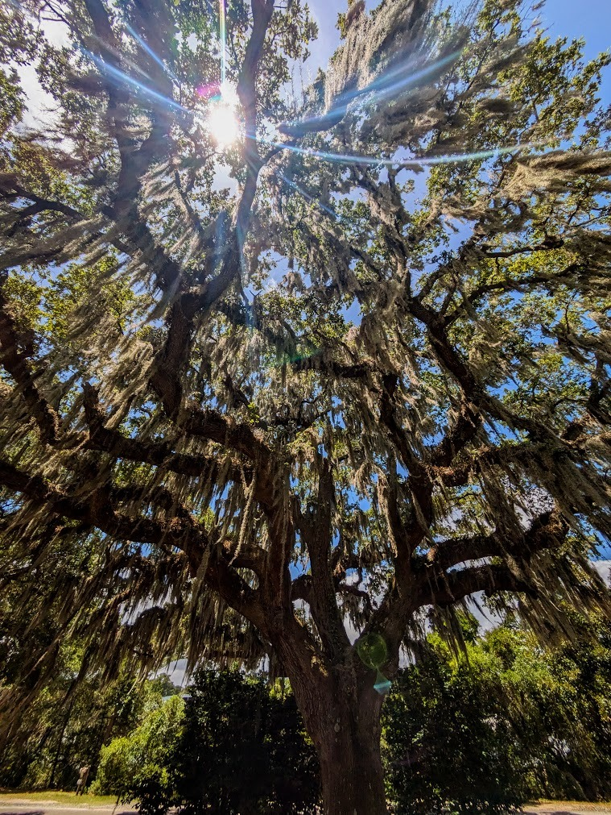
Elias Johnson
The Flavor of Solitude
There are days when the silence waits for me
like an old friend sitting on the porch,
hands folded, saying nothing,
yet telling me everything I need to hear.

I used to fear such stillness—
when I was younger,
the hush felt heavy,
as if the walls pressed in,
as if my own thoughts were unruly
guests I could not keep in order.
Loneliness then was sharp,
a blade without a handle.

But the years soften edges.
Now I find myself reaching
for the spaces between voices,
for the gentle pause
that opens when the world
finally stops demanding answers.

Alone, I begin to ask questions
that have no urgency:
Who am I without an audience?
What shape does my heart take
when no one is watching?
I discover that my spirit is not empty
but filled with low light,
like a lamp kept burning
for no one but myself.

In these hours, I walk the inner corridors,
naming my joys, my regrets,
sifting through them as though
they were seashells collected long ago.
Sometimes I hear a whisper
not my own—
a voice I cannot summon at will,
but which comes unannounced
in the hush of afternoon,
or the first blue hour of dawn.

Solitude, once an ache,
is now a sweetness that lingers,
a quiet feast for the soul.
It is not the absence of company,
but the presence of myself—
a presence deep enough
to brush against eternity.

Dale Crowley

Beauty is in the Eye of the Beholder

The eyes that see,
the nose that smells,
the hands that touch.
The hands that feel
what cannot be seen.
A brush of the hand
over the blades of grass.
The methodical prick of the green shoots
lightly grabbing on to keep you here.
To keep you near.
To keep you lying in the sea of possibilities.
The sea of little things
making insignificant reaches to the sky.
You watch an ant crawl up a strand of grass
like a giant climbing a skyscraper.
For a moment, you’re the giant.
You are overseer of all things.
The world in your hands.
But not really because there could be something
crawling around waiting for you to leave.
Waiting for you to love me as much as the earth loves to grieve.
As much as the butterfly loves to whisper.

Ava Mcwilliams

Fish
“It’s not gonna bite you, y’know.”
Carrie lifted her head and swallowed around her tongue. It was swollen and clumsy in her mouth as she watched her roommate prop herself up on her elbows and stare down at Carrie between her legs.
“Right,” Carrie breathed. She shoved her sweaty fists between her knees.
Em huffed and collapsed back onto her pillow, gazing up at the ceiling and fiddling with the lace of her bra. “You’ve seen a vagina before, right?”
“Right.” She stared at Em’s vagina. She had one of those, too. It shouldn’t have looked so alien, the wet folds and the wiry hairs and the swollen bud of Em’s clit. Carrie freed one hand, reaching with clammy fingers and brushing them over the inside of Em’s thighs, drawing a hiss.
“Cold,” Em said. “Look, Carrie. Wouldn’t it be easier if I touched you instead?”
Carrie flinched back and squeezed her legs together. “No. No, I—” She let out a large breath. “That won’t help me figure this out.”
Em stuffed another pillow under her head and pulled her vape out from her bra, exhaling sweet vapor through her nostrils and watching Carrie through the haze. Eventually, she shrugged. “Your choice, man. You’re the one who wanted to do this.”
Carrie nodded and couldn’t stop nodding. She shook herself out of her stupor and lowered her head, pressing a dry kiss to the left of Em’s entrance. Em didn’t twitch, but her hipbones rolled as she shifted her legs wider.
“You smell different than me,” said Carrie.
Em covered her face with one hand. “Jesus Christ.”
“Are you… turned on?” Carrie ventured.
Em hummed and shifted her hips. The muscles in her stomach bunched, and Carrie watched them, fixated. Em poked a finger into Carrie’s forehead, pulling her attention back. “Are you?”
Carrie considered this, turning it over in her head like a coin. She took her hand away from Em and pressed it between her own legs, waiting for someone to answer the question for her. She was wet, but no shivery heat ran through her at the touch. She remembered getting wet at her first gynecology appointment, spread open, her feet straining against the stirrups and staring up at the florescent lights until she could see them with her eyes closed. She hadn’t been turned on then, but her body had pumped its way through instinct as she’d flinched against the speculum digging into her.
Carrie pressed her nose into Em’s dark, coarse hair. She squeezed her eyes shut and shuddered.
“Hey.” Em sat up, fitting her hands around Carrie’s head. Her hands covered Carrie’s ears, and Carrie could hear blood rushing through them. Carrie trembled, and
trembled. “Do you want to stop?”
“I’m not doing this right,” Carrie whispered.
Em’s fingers dug into her skull. “You’re doing fine.”
Carrie pressed her tongue flat against Em’s clit and waited. She tasted: skin, salt, iron. Em released a long breath. Her hands relaxed on Carrie’s head. Carrie licked again. She closed her eyes and saw the vertigo green afterimage of florescent light. Tears ran hot on her cheeks. She focused on moving her tongue and breathing carefully through her nose, her own spit and tears getting snatched up into her nostrils with each shaking inhale. Spread open on the exam table, Em spread under her.
Jean Stitchfield

Moon Poem

The Moon is my home
Not the screaming walls It knows peace—I can tell
I don’t want that to be a foreign concept to me
Ironically, the moon is warm It soothes It comforts
Like a mother’s embrace It holds It cradles
When I weep, the moon understands It doesn’t call me sensitive
For it controls the tides already & I don’t want to go inside
So, I sit with the moon & it’s stars Until I have the ability
To be the Sun again

Jenna Tecchio

The Perfect Autumn Day: Hidden Bridge in the Woods

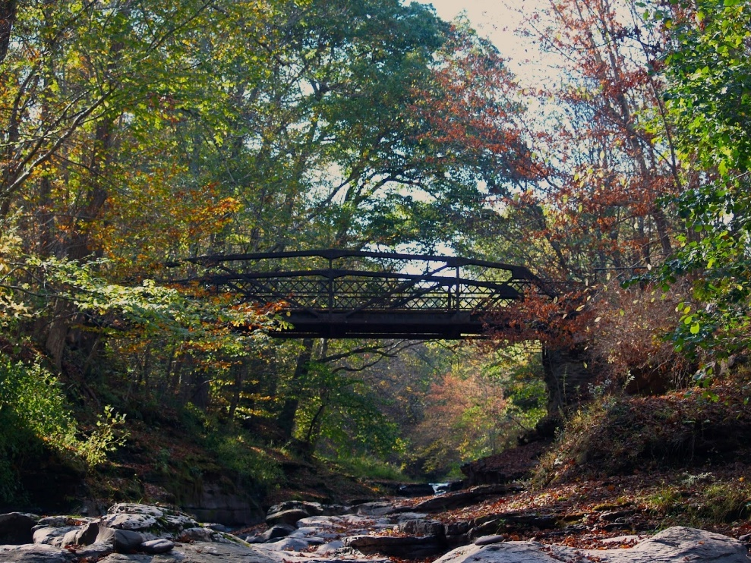

Anna Eastman

The Moon Thinks She Creates Her Own Light

She doesn’t realize she’s just reflecting the sun.
She actually has no way of producing light, but no one’s going to tell her.
She only glows in the presence of a larger, hotter being.
When it’s dark, she shines the brightest among the stars.
Even though the sun is down.
So who’s to say the light she shines does not belong to her.
When a grey ball of light shines through the blinds onto the pillow it’s not sunlight.
It’s moonlight.
From here we can’t see her dark side.
Neither can she.
She sees herself in the way we see her.
An angel illuminating the night.
Nature’s streetlight.

Ava McWilliams

Alien: Romulus

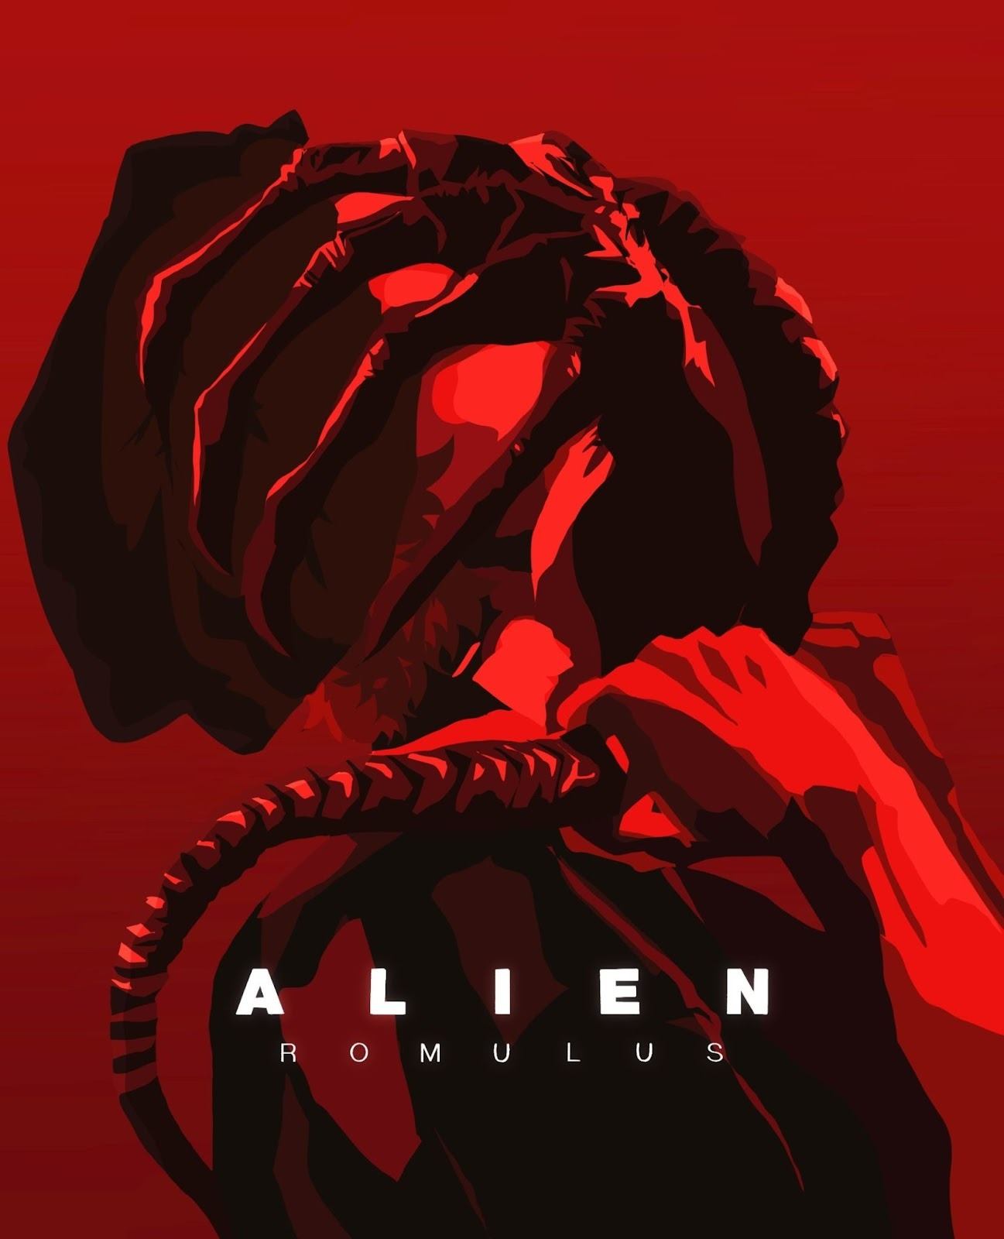

Mallory Reynolds
“Vampire Argument”
“They are pure evil. We would have to kill them.”
Outnumbered four to one, they clearly mean to stand firm
On their hypothetical what-if
They speak with sound logic, they are not incorrect.
But I have my own fierce, cloying thoughts.

Though I’d be prey, what if she were kind
Even if they were born of hell, what if she kissed me
Until the air left my lungs
Her teeth may be razor sharp, aimed to kill and steal
But what if that was only an appendage, and she were
Sweeter than summer berries

Summer berries
Would she think me as sweet as them? My blood plenty
And honey flowing down my legs?
Is this natural, to yearn for something so sinful
Something of Victorian longing and modern empathy

We’re wrapped in quilts in a mansion in the mountains
Her skin is a dove’s feathers, her eyes stained glass
I can’t resist curling closer to her, even if hunters and saints
Beg for me to escape the constricting fantasy.
I can’t.

I can’t stop thinking of the monsters we are meant to fear
Monsters created from the minds of humanity
I feel called to them, to embrace them like a lover.
I will share the youthful pink of my skin
I will share my heart
If it means that my love is in my arms.

Katie Waite
Shaping Margot
Valerie was the first woman I had ever seen naked…well almost. Sat on my bed with my butterfly covers over my head, It’s almost like I can hear my heart pounding as I flip the pages of the PLAYBOY magazine that I snuck out from under Alex’s bed last week– Alex is my older brother. My eyes are wide as I flip the cover page; her warm-toned, caramel breasts rest against the neckline of her white top. She’s wearing dark blue, ripped, jean shorts that stop just below her belly button. God, she’s beautiful. I wonder if I want her or if I want to be her—or both. I can see her nipples poking through her shirt.
“Comin inn- ya decent?”
Mom always checks nowadays since that one time she didn’t and happened to walk in on me forcing my C-cup titties into my A-cup bra. We don’t talk about it much. Ripping the blanket off my head and shoving the magazine underneath, I respond, “Yep yep, all good.”
Creeping open the door, she repeats, “Okayyy, comin' innn.” She drops my mesh laundry basket to the side and throws her hands up in the air, “Gotta check gotta check- don’t want a repeat of um… ya know.”
Like I said we don’t talk about it much.
She clasps her hands before inhaling deeply–she does that sometimes when she has something important to tell me or she needs me to do something for her. I don’t mind, I just find it funny she gets so serious. Moving to sit beside me, she says, “So, I wanted to talk to you about something, but I don’t want you to get upset or anything yet, okay?”
I frantically grab at the magazine in hopes of sliding it back with me as I push myself up against the headboard. My heartbeat has moved to my throat; I swallow it. “No yeah, what’s up?”
“Well, you remember your older cousin Kacey on your dad’s side?” After a beat of silence, she leans into me and whispers, “The lesbo.”
“Not really, but sure I think I’ve met her once or twice at a reunion. Why?” I’m trained to assume the worst when she brings up ancient relatives like this. I’ve only met Kacey a handful of times, but the times I have I couldn’t even muster up the nerve to talk to her cause the rest of the family hated her. I didn’t want them to hate me too.
“I don’t know a whole lot right now your dad just told me, but he said she and her ‘wife’ just separated and she needs a place to stay until she can get back on her feet…It’s only temporary,” she reassures me as though I was a complainant in this matter.
“Okay, yeah, how long’s she gonna stay?”
“Your dad says only a couple days– if we’re lucky.” She nudges me like we’re old pals and she’s just said an inside joke I’m supposed to know.
After a moment, she finishes chuckling and stands up, turning to face me though, and says, “Oh, and she’s gonna sleep in here with you if that’s okay.”
The lump in my throat that I thought had gone down was suddenly back, and I was choking on it.
“That okay?”
Clearing my throat and shaking the image of Valerie out of my head, I respond, “Sorry– yeah, no that’s fine. Yeah.”
She gives me a smile and a silent thank you as she moves back to the door– “Hey, are you sure this is okay with you missy? I don’t want you to feel like you have to say yes- I know it can be a little…uncomfortable to be changing and sleeping and all that with someone like that in the same room.” God mom. I decide to play her game and say, “I wouldn’t say it’s my first choice, but I guess it’s fine. I know this probably means a lot to Dad and you so.”
“Yes! Yes, it does honey. Alright, I’m gonna head back into the kitchen. Need anything?”
“Um, no that’s okay thanks though-” She starts to leave again– “Sorry, wait, um when did you say she was comin' again mama?”
“Shoot, I don’t know if I did– tonight. She’ll be here around dinner.”
This was also the first time I had ever imagined touching a woman. After a quick nod and a smile, Mom leaves me with my thoughts and the forbidden magazine under the covers. I throw the blankets back over my head for just one more peek; gliding my fingers over her figure I imagine how warm and soft the skin on her stomach is, how smooth her legs would feel against my prickly stems, the ridges on each of her nipples so mature and course poking through her itty-bitty top. I stop and move my fingers over her mouth- her lips are so plump and I wonder how she might taste. I don’t think I can say it’s a question now of whether I want her or not, but I hope to god I can deny it. I can’t lose my mom and my family; I love them so much, regardless of their hate. So, without a word, I rip out the picture of Valerie and fold it into a small square that I then slip into my pillowcase, but before I do, I peck the small, coated picture. I remove the blanket from my head and sneak out through the hallway, and past Mom in the kitchen, to the backyard where our big dumpsters are. Standing in front of the large recycling bin, I hold the magazine to my chest; I take a large inhale and exhale before tossing it in.
“Margott? What’re ya doin' honey?”
Wiping the wet from my cheeks, I answer, “Oh- yeah, yep all good, just taking out Alex’s trash.”
“Awe, thanks, hun. You’re such a good sister.” Heading back inside, I can just barely hear her mumble, “God that kid can’t do anything himself,” as she shakes her head in disappointment.
I’m not sure why, but I feel like I’ve just gotten away with something; I hate lying to her, but I’m not exactly sure what she’d think or say about me throwing out my older brother's porn magazine, so I guess it’s a win some lose some situation.

I can hear her Harley pulling into the stone drive outside my window– Kasey isn’t too much older than me, but no 22-year-old woman has ever been known to want to hang out with their little cousin– let alone sleep in the same small, purple painted room as them for 4 days straight. My bed is still not made and I’m rushing to rip the Backstreet Boys and P!NK posters off the wall above my bedside table. Flipping the covers up over my pillows and wrinkled sheets, I attempt to catch my breath before throwing my dark, curly locs up into a bun with the blue scrunchie I keep on my wrist. Finally, I hear the door slam shut and her Southern accent fills the halls– I race to the living room.
“- and then I said, ‘don’t you give me that tude mister or you’ll be out a tip if ya know what I mean’- Oh my goodnessssss! It has been too long! Is that you Miss Margot?”
I stop in my tracks. “It is, isn’t it? Here darlin, can you take these up to our suite please, and thank you?”
Finally, I shake out of the trance she’s put me in without even trying, “Oh, yes of course. Here, gimme those.” She shoves two duffle bags into my arms and shouts to me as I make my way up the stairs, “I’ll be up in a jifff-”
I plop her bags on top the futon mama put in here for her about an hour ago and inhale the scent of cinnamon and lemon coming from her belongings. Hearing her high-heeled boots clonk down the hall, I immediately jump into my bed and pretend to braid my hair and act like I don’t hear her approaching.
“Knock knock,” she says as she taps her knuckle against the doorframe. She points to the brown, leather futon on the other side of the room, “This mine?”
I nod and reply, “You got it and the bathrooms across the hall then.” The room falls quiet and I let my gaze land on her- she moves so slowly. So gentle, but sure. Her skin is light and covered in freckles. Her hair coils in red springs on her back and her eyes are a soft, but dark green. She’s wearing a lacey, white tank top tucked into her high-rise, Bermuda shorts, and bangles line her forearms. I watch her necklaces fall against her chest over and over as she bends down to reach her bags. Once she is done packing, our eyes meet.
“It’s okay I put my shit in there right? I guess I just kinda assumed these hangers were mine since they were on this side.”
After a hard blink, I reply, “Oh, yeah. Of course, all yours.”
“You don’t talk much do you?”
“Um… not really, I guess. Mama gets on me about it all the time.”
“Well, ya know what, that's alright. I like a little quiet now and then too.”
Not even a minute passes before she starts again, “Now are you in school then, Margot?-” She lights her cigarette, “Aren’t you like 12 or something?”
“13 now, actually, but yeah.”
“And how is thattt?”
“Um, it’s okay, I guess.”
“You guess? Come onnnn- no crushes? …Or anything excitin? I remember when I was your age and everything in the world was happening at once, come onnn… tell me all the juicy deets!”
“Oh, um… I guess theres this girl…”
Suddenly, I can feel her long fingers grasping my knee and her voice ringing in my ears again– after a huge gasp inward, she says, “O spillllll honey! Okay, okay what’s her name?”
I can’t help but feel weird telling her this, but inevitably, I lean forward and whisper, “It’s Valerie.”
“Ooo okay, Valerie, cute. And is she in your grade or what? How’d ya meet her?”
She talks so casually, so normal. I can imagine my mother now outside the bedroom door listening to me confess my sins to my Cousin I haven’t seen in years, then breaking down the door and pulling me by my ear to the church down on Richard. She would repeat prayers for forgiveness and cry at the loss of her clean daughter.
“Margot? Babe?”
“Huh? Sorry, what?”
“Well… how’d ya meet her doll?”
“Who?”
“Valerie?”
“Oh, yeah, right. Sorry. School… yeah I met her at school.”
“Well, that's really nice sweet pea, you’ll have to let me know how it goes then, okay?”
“Oh, yeah, sure. Course.”
She moves with such confidence and a lack of care. I wish to be like her someday and not my mom. I can’t help but wonder what brought my mom here- to this hatred, this disgust. It wasn’t my dad that’s for sure. He isn’t the most accepting, but he does his best with Kacey- he knows it is something he needs to learn more about. I wonder if she will ever accept that she just doesn’t know everything. I wonder if it was this town, her mom? I wonder if I will ever be able to tell her. When I finally come back to reality, I can hear Kacey snoring from beneath her yellow quilt. I look at the time and notice it’s now 8:47 pm– quietly sliding out of bed I slip into my only pair of satin pajamas. I shut the bedroom door and then silently wiggle back under my butterfly covers. Sliding my hand beneath my pillow, I feel the small, square sliver of paper against my fingertips– I pull the treasure out and open it, fold by fold. I admire her for who she is. Holding the photo to my chest, I feel her against me and fall asleep a happy girl.
Waking up the next morning… now that’s another story.
“BREAKFAST IS DONEEE!”
I hear her, but I don’t register it until she is hovering above me, heavy breathing. Once I finally do understand the situation, my eyes open wide at her less blurry figure hovering over me holding a small, square, slightly ripped photo between her fingers. Valerie stares back at me in disgust- or maybe that's just my mom because I’m honestly not completely awake. I throw my arms over my face in defeat and as I peek through the crack between my arms I see my mom motioning me to come with her and shaking her head as she walks out the door. I rise in a hurry, throwing sweats overtop my satin shorts and slipping my fuzzy socks on before I trudge past a sleeping Kayce to the living room couch where my mom is sitting, waiting for me. I wipe my eyes– I can’t really tell you exactly what I said whenever I sat down beside my mom because this was such a long time ago, but it was something along the lines of I love you and I’m sorry– the crusties coat my fingers. I take a deep breath. It is quiet. I look at my mom and she isn’t saying anything, she’s only crying and letting out sharp inhales the deeper the cry goes into her throat. She hugs me, tight. I let go and wrap my arms around her shoulders, feeling her snot and tears wet against my chest as she lets go too.
We are both crying now, but she releases her hold on me and begins to suck the snot back into her nose, wiping tears from her cheeks– I do too.
“I am… so sorry, my heartbeat.” I don’t say anything and for once she does not scold me for doing so. She continues, “I never want you to feel like-” she stops for a moment to sniffle and cry a second more, “- I never want you to feel like you have to hide this from me anymore.”
“It’s okay Mama-”
“It is not.”
I give her a look that is not disappointment or shame, but compassion and forgiveness– I know this because immediately she smiles and holds me to her chest like she did when I was young. She is not full of hate or born out of anger. She is human. “It is okay, we are okay.” Mama leans back and I lay with her, against her warm breast, and wait for the rest of the family to wake.
A loud baritone voice startles me awake.
“RISE AND SHINE LADIES.”
Another voice chimes in, sweet, but loud.
“Ya’ll aren’t even up yet? What’s goin' on around here? It’s almost 12 noon.”
Mama and I slowly get up from the big, corduroy couch and make our way to the dining room together where the breakfast wait, cold from earlier. She reheats it while I sit with the others and listen to Kayce talk about how “comfortable the arrangements were” and “sweet the hospitality was”, giving me a wink from across the table. Mama places the large, hot plate filled to the brim with steaming sausages closest to Dad and the saucers with mustard and ketchup closest to me. She runs back to the kitchen and returns with an oval bowl overflowing with fluffy, yellow eggs which she slides to Kayce’s side before rushing back to the kitchen. Finally, she comes back through the archway with two plates, one in each hand, towered with waffles on one and grilled hashbrowns on the other. There is already a gallon of orange juice sitting in the middle of the table, which I use to fill my cup quickly before we pray. Once we are all sat, Mama nods her head and we all bow ours, grasping our hands together as we listen quietly.
“Bless us, O Lord, and these Thy gifts, which we are about to receive from Thy bounty. Thank you for our guest and her safe travels as well as our restful night's sleep, Lord. And thank you Lord for our beautiful, beautiful children who bless us each and every day with their light… and their love. O’ Thank you, Lord Jesus…
Amen.”
“Amen.”
Squeezing my hand, she looks up at me with wrinkles, eyes I never realized were so deeply blue.
This was also the first time I had ever truly connected with a woman
Eloise Brewsy

My Body/A Book

I won’t write in my books
but I’ll tattoo my body.
Impulsive stick and pokes dot my fingers, thighs,
anywhere the needle reaches.
Dots turn into lines
words into sentences.
Whoever thinks the body is more sacred than a book
hasn’t caressed the untouched pages that litter my shelves.

I won’t crack the spines of my books
but I’ll pop my knuckles.
Every morning, I stretch my fingers, toes,
until each joint is satisfied.
Discomfort turns into satisfaction
Discontent to still.
Whoever thinks my books are more unblemished than my body
has seen the ink that litters my skin.

Kacey Sollenberger

A Moment in the Passage of Time

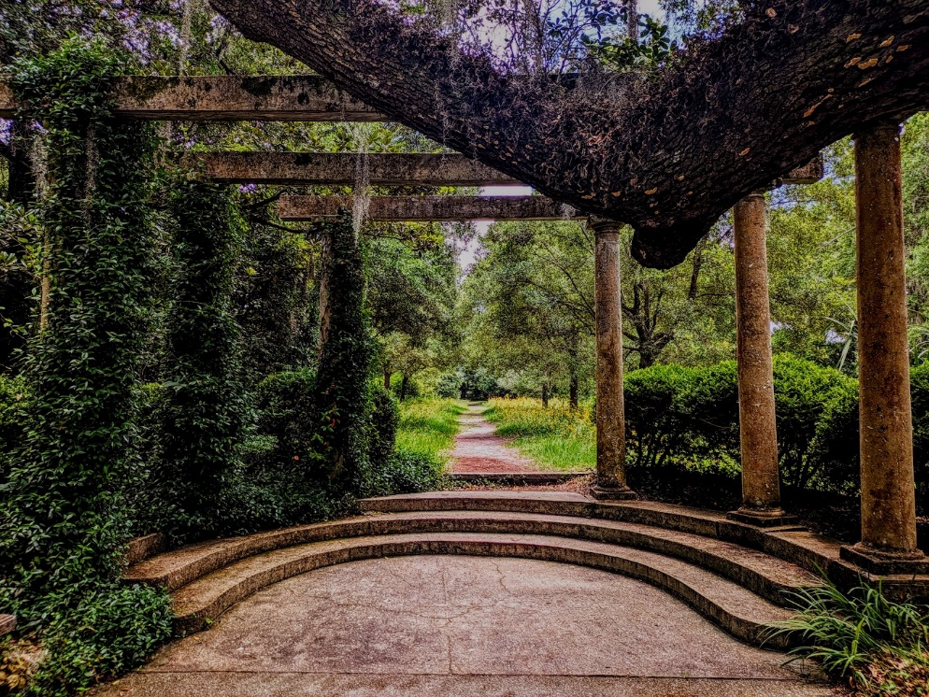

Elias Johnson

Willow in the Spring

She is a willow in the spring.
Tall and thin, with branches and limbs swaying effortlessly and gracefully.
She moves with the wind; and dances to the songs of bluejays and the babbling of a glistening stream.
The sunlight shines through her leaves, warming them, cascading through in a warm blonde light.
She’s grounded and will forever remain. The roots deep, the foundation sturdy and unwavering.
The bark guarding her can be thick and tough, but the lumber within is soft, welcoming, and whole.
A willow in the spring.
Lithe and enrapturing.

Lauren Pool
Goblin Party

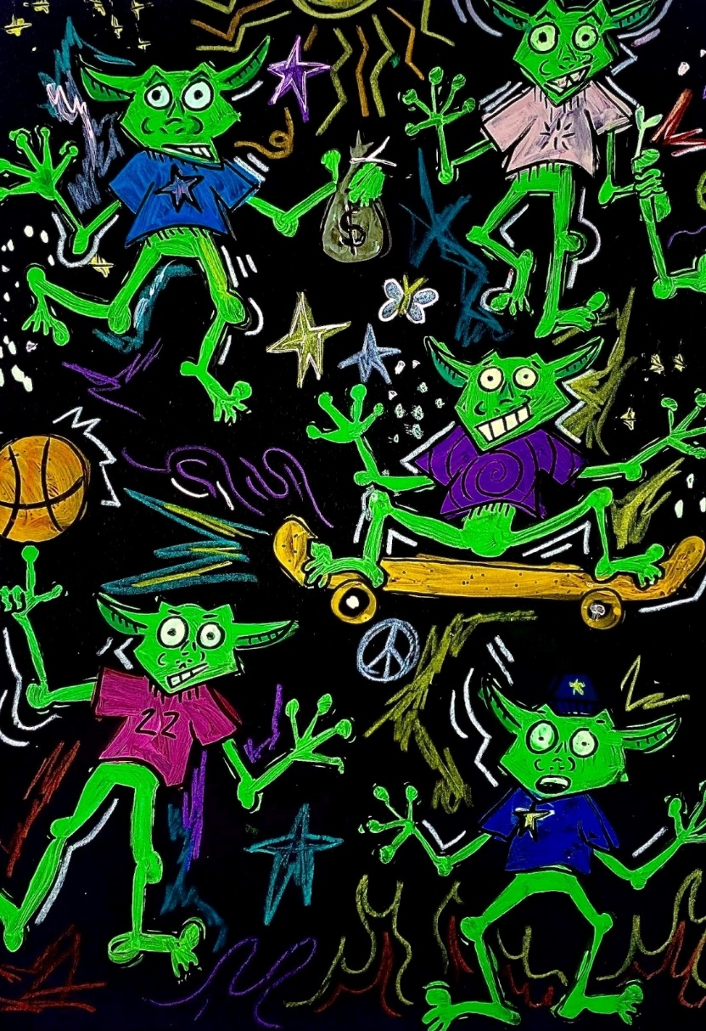

Rose Emenheiser

the grapes’ rainbath

the clouds above coil and sway like a restless dream,
and we lay awake, watching,
bothered not by the gravel beneath us,
nor the incessant buzz of nature.

we imagine what it would be like to soar,
to swirl through cerulean skies.

the groundlings will marvel at our majesty,
each one envisioning us as
sheep, or birds, or grapes picked
ripe from the bunch, plucked from
their homes and flung skyward,
and on those blessed souls,
we will rain grape juice.

Daniel Wintersgill
Sunset
Olli gazed at the scarlet-tinted clouds streaking across the horizon, lifting his face toward the sky as a light breeze ruffled his hair. He let his eyelids droop and sighed deeply, feeling the heat from the sun on his skin. His sigh was reproduced by Jae to his left and Olli opened his eyes slightly to glance at him.
He meant to only glance at him quickly, but his eyes got caught on Jae’s long eyelashes and the way the amber sunlight broke through the trees, dappling his freckled face. Another breeze came by, stronger this time, tousling Jae’s curly mullet. Olli felt blood rush to his cheeks, and he allowed his gaze to linger a few seconds longer before lowering it to his slightly parted lips. His eyes wandered from one corner to the other until resting on his bottom lip. A small amount of dried blood peaked out near the inside of his mouth, while the rest of his lips were coated with a lightly pink-tinted lip balm. Olli trailed his gaze over Jae’s collarbones, then his biceps, and finally the outline of his pecs through his shirt as he swallowed the growing lump in his throat.
“Olli, what are you doing?”
Olli caught his breath as his eyes snapped up to meet Jae’s. One of his brows was raised and his eyes were narrowed, but Olli could see a flush of pink dusting his cheeks.
“Nothing,” Olli responded, fidgeting with the collar of his shirt.
His face felt like it was on fire, and he whipped his head around to face the horizon again. Out of the corner of his eye, he saw a small smirk form on Jae’s lips.

Hailee Rauch

Palette of Life
Greedily, I dip my fingers into a painted palette placed before me
Smearing the colors, I work towards an unguided masterpiece of my own design
Until the women who have lived before me present their possessions
Perceived positives and negatives
My mother brushes handfuls of brown sugar onto my scalp and sprinkles some in my eyes
A vile of clear sky is injected by my NanNan just below the skin,
Blue life pulsing through my body
As particles of grass swarm my nose and I sneeze alongside my aunt
I take, take, take
Stealing their features in attempt of sharing in their beauty

Alyssa Sheriff

Bee Mine

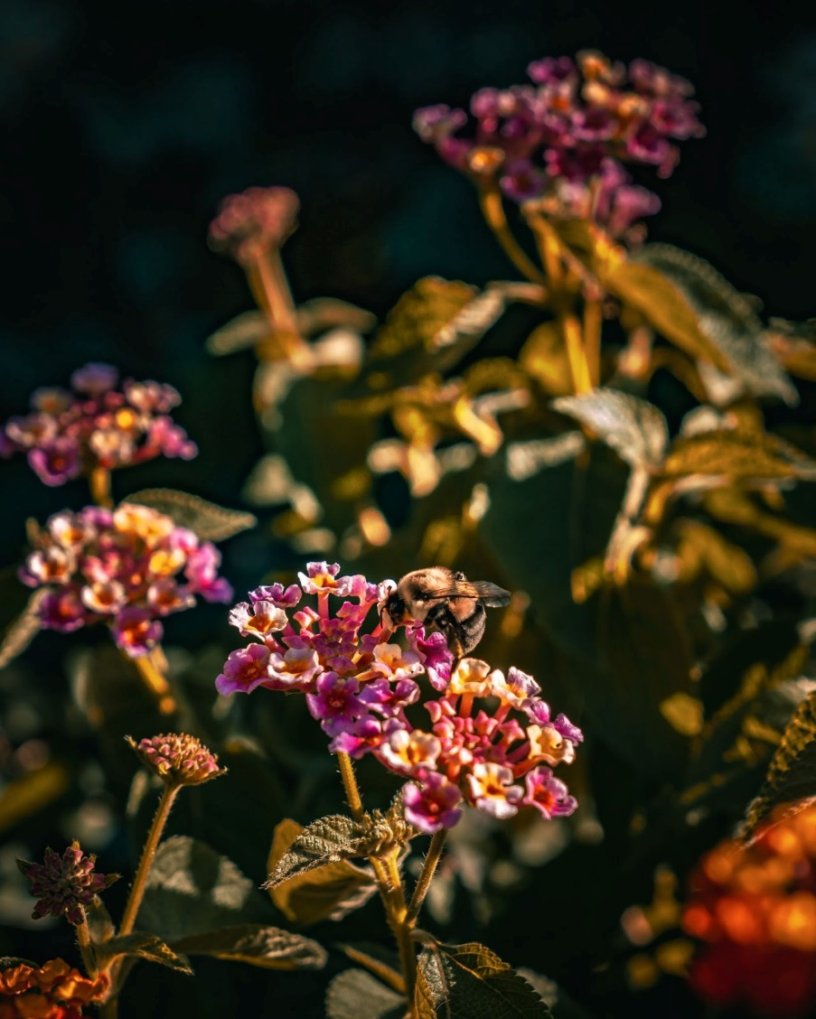

Noah Guillaume

I Fear

That someone will never love me
In the way I want to be
That someone will love me too much
And I will lose the person I am
I want that other half so badly
But I’m scared that my broken bits
Will be overwhelmed in the process
How could someone bring me in
And hold me close without
Ripping me through even more?
My scars are a deterrent
To those who won’t put in
The work to stand beside me
I need someone like ice cream
Someone who fills in the cracks
But doesn’t overtake the meal

Kleio Mae

Untitled

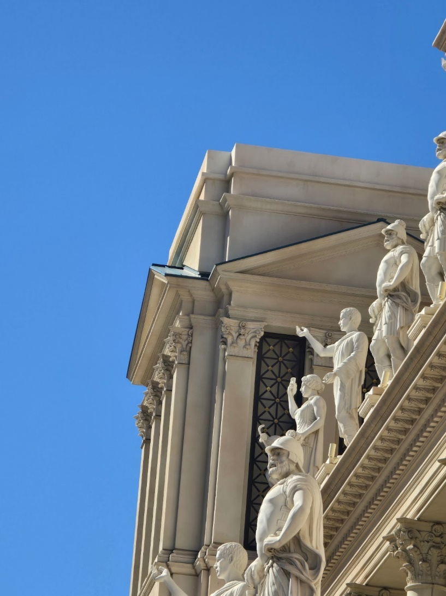

Gretchen Steel

His Harvest

six feet under your corpse feeds the soil of my future
your mangled hands tend to the garden of my soul
my basket, a cornucopia overflowing

apple—to bring me love, someone to call
pumpkin—to carve like we always used to, an old
chestnut—to provoke thought, as tasteful as
rosemary—to remind me of an endurance as green as
sage—to encourage longevity, to remind me I should have
thyme— always missing from the harvest

the one thing taken from you
the one thing you can not give me

Kylie Saar
The Days After It
Part One
The late afternoon sun warmed Karsyn’s back as he rested his elbows on his bed, a crinkled piece of paper between them. He hummed along to his radio playing “Someone Gets Hurt” from the Broadway version of Mean Girls as he lightly sketched some ruffles into a dress design he had created in a previous art class. A slight, warm breeze drifted through the window, scattering several papers of costume sketches and set designs out of their perfectly stacked piles on the bed. Karsyn’s hands flailed across his bedspread as he tried to stop as many as he could from flying around his room.
“Having trouble, Kar?” A voice from behind him made Karsyn jump and whip his head around.
“Shit, Rex! You scared me,” Karsyn exclaimed, standing up. “What are you doing here?”
Rex smirked a little. “Don’t act like you aren’t happy to see me,” he teased, bending down to grab some of the scattered papers around Karsyn’s feet. “I was just in the area, and I happened to notice that a certain someone’s window was open, so I let myself in. Is that a problem?”
This wasn’t a new occurrence. Rex had a tendency to sneak in through Karsyn’s window; although it was typically late at night when Rex couldn’t sleep. He would usually arrive close to 2am, fall asleep in Karsyn’s bed and be out around seven before Karsyn’s mom did her daily check-in. He joked that Karsyn was his melatonin.
Karsyn felt his face flush as Rex stood back up, holding a stack of papers. His face was only a few inches from his own. “N-no, I am happy to see you,” Karsyn stammered, taking the papers from Rex. “It’s just, you know that my mom can’t know you’re here.”
Rex stared at Karsyn for a moment before widening his smile and wrapping his arms tightly around the shorter boy’s shoulders. Karsyn let out a gasp as Rex pushed his body against him, knocking them both backwards onto the bed. The papers they had just gathered once again scattered across the floor.
“I don’t care anymore,” Rex said, adjusting his grip so he could bury his face into the nape of Karsyn’s neck. “Let her find out that I’m here. I’m so over keeping us a secret.”
Karsyn’s face burned. “Rex—”
“I know, I know. Just wait a few more months. I remember.”
“Thank you, love,” Karsyn cooed, planting a kiss on the top of Rex’s head.
“Fucking Eagle, Nebraska,” Rex grumbled.
Rex was originally from Philadelphia, so he wasn’t used to having to hide his identity in a small, conservative town.
Karsyn placed his hand on Rex’s cheek and pulled his face up, so he could look into his eyes. “As soon as we’re at Ithaca, we won’t have to hide anymore. From what I’ve seen, everyone is really accepting.” He rubbed his thumb over Rex’s skin. “And we’ll have our own room. We can do anything we want.”
That playful smirk reappeared on Rex’s face. “Anything?”
Leaning forward, Rex pressed his lips against Karsyn’s. Karsyn wrapped his arms around Rex’s shoulders, pulling him closer. His lips parted slightly, allowing Rex’s tongue to enter. He felt his tongue swirl around his own rhythmically, almost like they were dancing, causing a familiar heat to rise between his legs. Karsyn shuddered as Rex ran his fingertips down the front of his shirt and slipped his hand under the waistband of his shorts.
Karsyn smiled against Rex’s mouth. “Your hand is so cold,” he mumbled with a laugh.
Rex pulled back and grinned. “Oh, yeah?”
Karsyn shrieked as Rex pressed both of his palms against Karsyn’s sides. He giggled as he rolled around in the bed, grabbing at Rex’s wrists in an attempt to free himself. Rex followed in pursuit, rolling with him and straddling his lap, successfully pinning him. A paper crinkled beneath them.
Rex released his grip on Karsyn to pull the paper out from under him. Before he could fully examine it, Karsyn grabbed his hands.
“Don’t,” Karsyn said, suddenly serious.
“Is this not just the sketch you drew for art class?” Rex asked.
“I’m adding some things.”
“Can I see?”
“It’s not done.”
“Please?”
Karsyn let go of Rex’s hands, allowing him to bring the paper up to his face. “It’s embarrassing.”
“It’s cute,” Rex whispered, looking over the new additions of lace and ribbons.
“Huh?”
“It’s impressive,” Rex corrected himself. “Besides, when have I ever cared that you like to design dresses?”
“I guess I’ve just been feeling a little self-conscious,” Karsyn responded, fidgeting with the collar of his shirt. “I keep telling people that I’m only interested in set design.”
“You shouldn’t be,” Rex said. “You’re insanely talented at this stuff. If the people in this bumfuck town really have a problem with a boy liking dresses then that’s their problem, not yours. Hell, I’d wear your designs.”
Karsyn snorted. “You?”
“What? Can’t imagine me in a dress?”
Karsyn burst out laughing as Rex hopped off the bed and began to twirl around the room, pretending to hold up the bottom of his dress. This was cut short, however, when they heard footsteps approaching the doorway.
“Shit, it’s my mom,” Karsyn whispered, quickly sitting up. “Hurry up and hide somewhere.”
Rex rushed towards the closet as the doorknob began jiggling. He had just barely made it partially behind the laundry bin when the door swung open.
“Were you talking to someone?” Karsyn’s mom asked, scanning the room.
“I was just singing,” Karsyn responded, gesturing to the radio as he pushed his scattered sketches into a makeshift pile on his bed.
“Well, your grandmother is here for dinner,” she continued. “Don’t make her wait.”
“Yes ma’am,” Karsyn said, watching nervously as his mom did one last scan of the room before closing the door behind her.
“Your mom must be blind or something,” Rex said, emerging from the closet. “I think my foot was sticking out.”
Karsyn sighed as he got off his bed to turn off the radio. “Well, thank God because honestly, I was freaking out.”
Rex ruffled Karsyn’s hair. “You’re so cute. Now go eat before your family has a conniption. I’ll let myself out.”

“Your mother tells me you’ve picked a college?”
“Yes, gramma,” Karsyn responded, his fork scraping over a few pieces of rice on his plate. “I’ll be going to Ithaca College in New York.”
His grandmother sipped on a cup of tea. “I’ve never heard of it. What kind of school is that anyway?”
“It’s a liberal arts college,” Karsyn said. “It’s got a really good theatre program.”
His grandmother’s eyebrow raised. “Theatre? Fiona, sweetie, I thought you said he was going into architecture or something.”
“Set design, mother,” Fiona corrected. “Carl and I tried to get him to do something actually useful with his talent for design, but he just wouldn’t listen.”
Karsyn’s grandmother stirred her tea, the spoon clinking lightly against the glass. “That’s a shame.”
Karsyn felt blood rushing to his cheeks. He focused on picking up one lima bean at a time on the prongs of his fork.
“So, Karsyn,” his grandmother continued. “Do you have a girlfriend yet?”
He looked down at his plate, counting ten lima beans on his fork. “No.”
“A handsome boy like you should be looking for a nice young lady to settle down with by now. I have this friend in my Bible study group with the sweetest granddaughter. She really is the nicest girl. Maybe I should give her your number, hm?”
“No, I—”
“No, mother. Karsyn already has lots of little girl friends,” Fiona interrupted, giving Karsyn a tight smile. “Honey, you always used to talk about the girls you hung out with at school. What about that short girl you brought around to work on your art project with? What was her name? Delainy? She was cute.”
“Delilah and I are just friends,” Karsyn said with a sigh. He squeezed a fifteenth lima bean onto his fork.
“Whatever. Maybe you could invite her over again some time,” Fiona said. “I’m just glad that you aren’t hanging out with that Rex boy anymore. He was such a bad influence.”
Karsyn whipped his head up.
“That kid was always wearing ripped jeans or chains or something stupid when he came around here,” Fiona rambled on. “I could have sworn that I saw him wearing eyeliner one time. I wouldn’t be surprised if he was one of those homosexuals.”
Karsyn winced.
“He sounds like a real nutcase,” Karsyn’s grandmother said.
“Oh, he was,” Fiona responded. “Although, I almost feel bad saying it. His parents divorced a couple years ago. I heard his father left his mother for a younger woman. That’s probably why he’s so messed up in the head. I’m so grateful that he stopped coming around here before he infected my baby’s mind.”
Fiona continued on to her mother, but Karsyn tuned out the rest. He remembered the defeated look on Rex’s face when he opened the front door one Saturday afternoon in the middle of their sophomore year. His eyes were red, and the shoulder of his T-shirt was stained with tears. He fell into Karsyn’s arms, and he held him for hours, right there on the floor in the entryway of the front door. He remembered the intense ache in his heart as Rex’s body shook with sobs into his chest. Karsyn had never cared about anyone more than he cared about Rex right there at that moment despite only knowing him for a few months. After that day, the two became inseparable.
“Karsyn?”
His mother’s voice jerked him out of his thoughts.
“What’s wrong, honey? You got so quiet.” Her hand was resting on Karsyn’s wrist.
Karsyn snatched his arm away from her, his fork clattering against his plate. “I’m not feeling very well,” he said. “May I be excused?”
One of Fiona’s eyebrows raised. “Well, alright,” she responded, hesitantly. “Go put your plate in the sink.”
Karsyn did as he was told, slipping his plate into the sink and rushing back to his room. He took a deep breath, trying to push the events of the dinner out of his mind as he pushed open his bedroom door.
“Well, finally! It feels like you’ve been gone forever.”
Rex was sitting at the head of the bed with one of Karsyn’s sketchbooks resting open on his lap. He wore one of Karsyn’s Mean Girls shirts and a pair of his pajama pants that just barely reached the bottom of his calves. Rex beamed up at Karsyn as he approached the bed.
Karsyn found himself smiling despite how angry he still was. “What happened to seeing yourself out?” he asked, sitting down next to Rex on the bed.
“So, here’s the thing,” Rex explained. “I did leave after you went downstairs for dinner. I went home to spend some time with my mom. I heard her on the phone crying earlier today, so I wanted to check on her. I assume it was my father. Whenever he calls to ask how my sister and I are doing my mom always gets a little bit emotional. Between you and me, I don’t think she ever really fully got over him after he cheated.
Anyway, after I got home, I went into my mom’s room to ask how she was doing and she completely ignored me. Like, I’m talking didn’t-even-look-in-my-general-direction level ignoring. Can you believe that? I kept trying to talk to her, but she acted like I wasn’t even there. My sister is at her friend’s house, so I couldn’t even ask her if something had happened.”
“That doesn’t sound like your mom at all,” Karsyn said.
“I know, right? But the more I thought about it, I realized that maybe she is just pissed that I snuck out to see you last night. I left before she fell asleep, which was probably a bad idea. I guess she noticed I was gone.”
Karsyn blushed as he remembered the events from the previous night. “I guess. It’s still kinda weird that she ignored you.”
“Yeah…”
The two were silent for a moment as Rex rested his head on Karsyn’s shoulder. A slight breeze drifted in through the slightly cracked window. The room was quiet except for the occasional frog croak from outside.
“I feel bad,” Rex said finally. “Maybe I should’ve stayed with her. I was just so pissed that she was ignoring me. Do you think I should go back?”
Karsyn shook his head, his face rubbing against the top of Rex’s hair. “She probably just needs some time to cool down. Try talking to her again in the morning. I bet she’ll be back to normal by then.”
“M’kay,” Rex responded quietly.
Rex suddenly lifted his head up and grabbed Karsyn’s hands. “Oh my God, I’m such a fucking jerk!” He exclaimed. “I didn’t even ask if you were okay. You looked so sad when you walked in and here I am, rambling about my own problems like an idiot. Did something happen at dinner?”
“Rex, love, you’re fine,” Karsyn said, squeezing his hands. “It was the same thing that always happens when gramma comes over. It just messed with me more than usual tonight.”
“Do you wanna talk about it?”
Karsyn felt rage bubbling up inside of him as he recalled his mother’s description of Rex. He pushed this feeling back down, mentally reminding himself that he only had two months until he and Rex would be on their way to college. “Not really,” he responded.
“Wanna go for a walk? That should clear both of our heads,” Rex said.
Karsyn gave him a small smile. “A walk sounds nice.”
There was a light, cool breeze in the air contrasting the earlier heat as the two boys walked side by side along the sidewalk. Every so often, their knuckles brushed against each other, but they didn’t dare hold hands. There were several families outside, enjoying the nice evening. Across the street was a group of elementary school children. Their giggles echoed through the town as they chased fireflies around their yard.
Rex looked down as the town’s priest who was keeping an eye on the children waved at them from his bench on the porch. Karsyn gave a small wave back. As they turned the corner, Karsyn almost didn’t notice an older man heading straight for them. With a slight gasp, the old man stepped out of the way for Karsyn, putting himself directly in front of Rex instead. Rex barely had time to leap onto the grass, preventing the man from barreling into him.
“What the fuck was that?” Rex shouted, whipping around.
The old man kept walking, disappearing around the corner.
Rex turned to Karsyn, a look of shock plastered across his face. “You saw that, right? I’m not going crazy?”
“Ignore him. This town is full of assholes,” Karsyn said. “Come on, let’s go get ice cream.”
“I don’t get it,” Rex complained, following Karsyn as he continued down the sidewalk. “I’ve been living here for almost three years and everyone still hates me. Like, what did I even do to these people?”
“Have a personality,” Karsyn replied dryly. “People around here hate anyone who isn’t a carbon-copy of them. They wouldn’t like me much either if I didn’t hide who I truly am.”
“A bottom?”
“You’re a perv.”
“Just trying to lighten the mood.”
Karsyn laughed and gave Rex a friendly push as they neared the ice cream parlor in the center of town.
The shop was quite old and rundown. Some of the windows were shattered and the roof looked like it was one rainstorm away from collapsing. It looked like it hadn’t been renovated since the 80’s. Rex hesitated at the door. “Would you mind if I stayed out here?” He asked. “I think I need to sit down.”
“Everything okay?” Karsyn asked.
“Yeah, I think so,” Rex responded. “I just feel a bit dizzy all of a sudden.”
“No worries,” Karsyn said, rubbing Rex’s shoulder. “Go sit on that bench by the street post and I’ll meet you there with your ice cream.”
“Thank you, Kar,” Rex said.
Karsyn was greeted with a chime from the bell as he entered the shop. There was a surprising lack of people inside for such a nice night.
“It’s slow tonight,” he commented to Doug, the owner of the place.
Doug grinned. “I think there’s gonna be a storm soon,” he responded. “Now, what can I get’cha?”
“What?” Karsyn looked over his shoulder and out the window at the sky. The stars twinkled brightly against the dark blue background. There was not a cloud in sight.
“I asked what kind of ice cream you want,” Doug responded.
Karsyn turned his hand back around to stare at the man for a moment. Doug had been the owner of this establishment since Karsyn’s mother was a teenager, so he was getting old.
“Yes, sorry, Doug. I’ll have two soft serve vanilla cones,” he said.
After only a few seconds, Doug handed him the ice cream.
“Enjoy your evening,” Doug said, a smile plastered across his face. “Oh, and son, make sure you stay inside for the next couple of days. Something tells me this storm is gonna be a big one.”
Slightly confused, Karsyn left the ice cream parlor and headed toward the bench where he told Rex to wait. As he got closer, he noticed that Rex was staring up at the street post. Karsyn quickened his pace.
Rex looked at him with wild eyes as he approached. “Karsyn…” His voice was strained and shaky.
“Rex, what—"
The ice cream cones slid out of his hands, splattering against the ground as Karsyn noticed the flyer stapled to the post.
Printed across a photograph of Rex’s face was the bright red word: MISSING
Hailee Rauch
Little Girl
I hope that little girl likes who she sees
I hope she’s proud that we’re still writing
That we took a creative writing class in college
Remember how you cried because your friends
Dug up that story you threw away,
Because you didn’t want anyone to see it?
You read your stories to everyone, little girl,
And you cried because you were so happy
Your first short story got published, too,
So you don’t have to hide that notebook anymore.
I hope she’s happy to know that she still has
Her room decorated in pink and butterflies,
That she collects the cutest and softest
Of blankets and stuffed animals.
I think she’d be glad to know that I adorn myself,
In the same ribbons and frills that she was afraid to wear
Because she didn’t want to stand out.
But we got no choice to stand out,
Because we’re sure as hell different from everyone else
So why not make it grand and embrace it?
You didn’t need to hide anything, baby girl,
Because there was nothing to be ashamed of

Rebekah Garrido

In Utero: 2

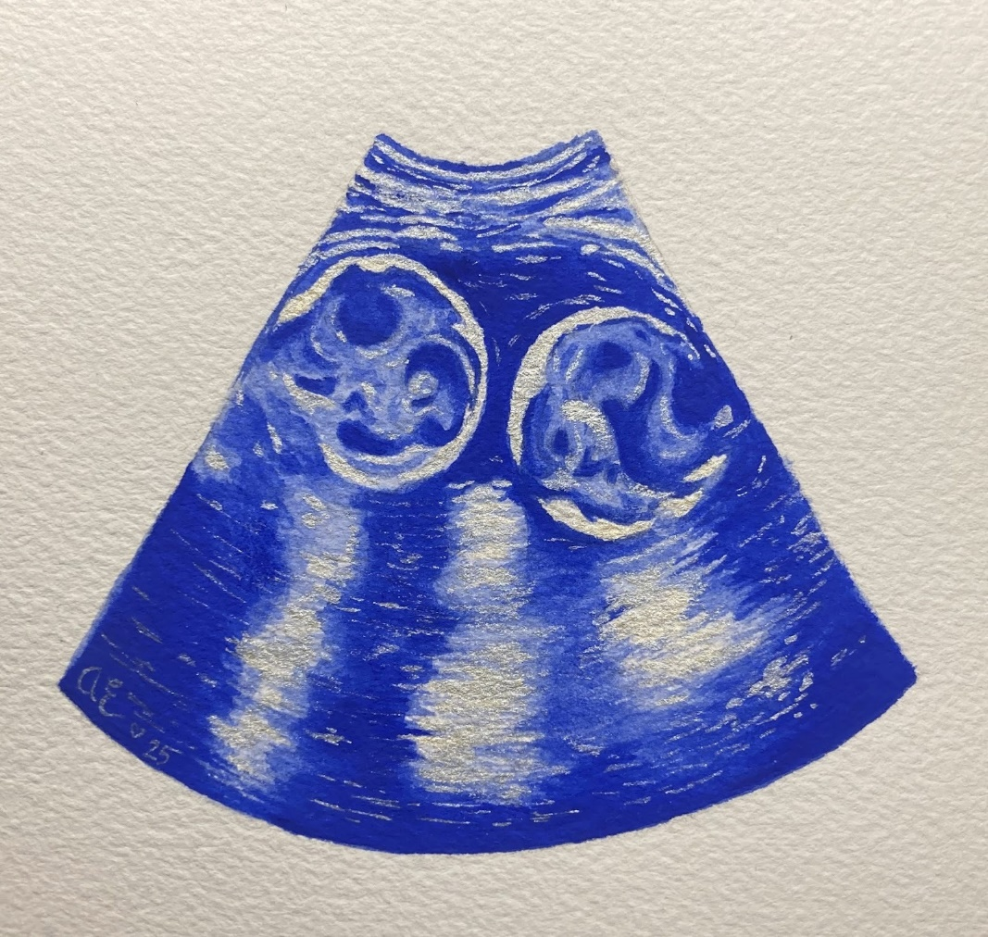

Anna Eastman

Well Loved

We have a special saying in our family
about things that are dulled,
that they’re not broken,
but that they’re
“Well loved”,
cause we use these things
until splinter and thread
and polish and furbish and
pass down where they’re lead.

Hot pads that are stained and unraveling.
Bowls with chips and fleeting enamel.
Baskets with the straw and twine fraying out.
and pencils whittled down to their nibs.

Acid washed jeans with patches on patches,
T-shirts with holes on holes
Shoes glued back onto their soles and soles
worn down to nothing

Candle jars now turned glassware now turned
Flowerpots now turned paint cups,
And Coats turned into smaller coats
turned into dry cloths turned into sewing scraps

Salt and pepper shakers being passed down
generation after generation
each one shined and buffed as its handed by.
Ceramic pots being given away,
collecting dust from every destination

Chipped dressers are repainted and re-stained.
Cookbooks reread and repeated.
Classic cars are repaired and renewed.
Cookie Jars recleaned and refilled.

People
are well loved because
People
are worn out and
People
are fractured
And sometimes they’ll never be fixed.

They still live on
through the beaten and bushed,
the crumbled and crushed,
because they are loved
well enough.

We have a special saying in our family,
about people that are worn down,
that they’re not broken
but that they’re
“Well loved”.
Their cards don’t define them
as they endure and press
cause they spend their time
till their last passing breath.

Kaylee Will

The Best Stardew Bachelor

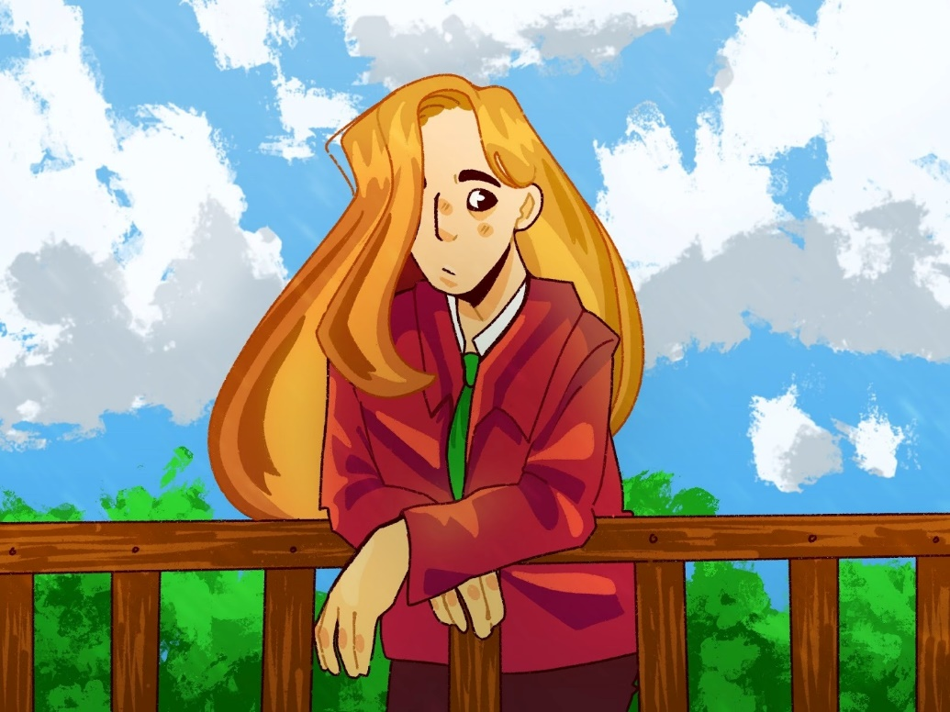

Mallory Reynolds

Rotten Fruit
I laid under an apple tree
to find refuge from the sun
limbs splayed, palms open,
I slept

A fruit plummeted to my hand
waking me from slumber
my eyes fell to the apple
bright, shining, red as anger

My fangs ripped into its
deceptively perfect flesh
only for the taste of decay
to wash over my tongue

Down my esophagus
fusing with saliva
traveling to meet
dread in my gut

Seeds of rot
planted themselves
in my stomach
roots grasping my organs

I did not know stomach acid
was the most fertile soil
for something so full
of vile

Maggots writhed out
Burrowing deep in my muscles
Ingesting smooth tissue
worming to adipose

Was the apple aware of its rot
when it leapt from the tree
and delicately deposited herself into my
hand?

I did not pick the apple
and yet
I parted my lips
I let her in

I consumed her rottenness
let it fester inside me
my body, eaten from the inside out
as she consumes my very essence

In a desperate attempt to
devour me
become me

Am I rotten now too?
Kylie Saar
Things Left Behind.

She found it on a shelf in the attic.
It’d been hidden behind dusty picture frames and cobweb-coated boxes filled to the brim with old knick-knacks and things someone had meant to get rid of but forgot about. Despite all that, its surface remained clean and untouched. The leather was pristine, the golden clasp held no rust, and there was a certain smell to it, like it’d just been purchased from a craft store and not sitting in stale air for years on end.
She could hear her fiancé moving around downstairs, placing boxes in different rooms to make unpacking easier. His footsteps made the floorboards creak, reminding her of her Nan’s house that she often visited as a kid.
“Ella!” She tore her gaze from the box for a moment, glancing back at the opened hatch that led down to the second floor. “Where do you want the random stuff placed?”
“Just set it in the dining room with the rest of the boxes! We’ll figure everything out once we start unpacking!” She got a loud yes, ma’am in response.
Ella took a moment to look around the rest of the attic. There were wooden shelves lining all four walls, each stacked with a multitude of things from yearbooks to snow globes and old sports equipment that Ella was sure Dylan would love. Why the previous owners hadn’t taken any of this with them was lost to her, but at least she could make some money from them.
She returned to the shelf holding the box. Something about it was drawing her in, and it wasn’t the fact that it was clean in a room full of dust. There was this odd quality about it that made her want to reach out and open it, but if horror movies had taught her anything, it was to never touch something that looked weird. And the last thing Ella needed was a haunted house or a curse on her bloodline.
So, ignoring the voice in her head telling her to grab the box, she turned on her heel and headed for the ladder. Dylan would need help with organizing everything. The guy was great at many things—cooking, menial labor, handling her odd little rants about things that sometimes never made sense—but he couldn’t organize anything for his life. It was one of the many things she loved about him, but shit did it piss her off at times.
Ella was about three steps down when she heard it.
Creeeeeaaaaak.
She froze. Every molecule in the room screeched to a halt, as if holding its breath. Her blood felt like sludge in her veins and her lungs cramped up inside her ribs. She didn’t dare move, her hands gripping the ladder rungs so tightly they were stark white, blue veins creating rivers along her skin.
Ella waited, heart pounding in her ears. A minute passed, maybe more, most likely less, and no noise followed. She released a breath, chalking it up to the house settling or something, and looked up just to make sure nothing had moved in the attic. Maybe she’d bumped into something on her way out and caused it to adjust? That had to be the case.
“Stop being paranoid, El. You’ve watched one too many movies.”
But when she looked over the shelves, her eyes stopped on the box. It remained behind the boxes and dust, but something had changed. The golden clasp was no longer closed tight. It was as if someone had flicked it up, the hinges squealing after years of no movement.
“Maybe it was like that when I got here?” She knew that wasn’t the case, but Ella didn’t want to think about what could have opened the clasp. If she allowed herself to wander down that path, she’d lose her mind and ask Dylan to move back to their old apartment. Neither of them wanted that, so she ignored the dread clutching her heart in a vice grip and continued down the ladder.
Nothing else moved or creaked as she reached the floor, the stiff air of the attic replaced by the smell of fresh paint and lemons. Dylan must’ve started plugging in their wall scents. He’d always hated the smell of new houses. She’d asked him one time why that was and he’d just shrugged.
“Smells like unwanted memories,” he’d said. “Like those before us had left somethin’ behind when they moved. And I, for one, don’t want anyone else’s baggage on my shoulders aside from yours.”
Ella had just laughed and kissed him in the old kitchen of their apartment. But after seeing everything that was left behind in the attic, she was glad he’d started ridding the place of its old smell. Something about fresh paint and dust made the weight on her chest grow heavier.
“Ella!” She jumped as Dylan appeared around the corner, a few boxes stacked tall in his arms. His head was leaning to one side so he could see, a wide grin on his freshly-shaven face. “Done lookin’ at the attic?”
Ella nodded, walking over to where he stood to put as much distance between herself and the attic hatch as possible. “Yeah. The last owners left a bunch of shit up there. We’ll have to go through it all and see what we can pawn off and throw away.”
Dylan hummed and pressed a quick kiss to her cheek. “Well, I’m gonna set these last few boxes in our room and then we can order pizza or somethin’ before unpackin’. How’s that sound?”
“Perfect.” Ella slipped past him and started down the stairs, casting one more wary glance at the attic ladder before it disappeared behind the wall.
“Holy shit. You weren’t kiddin’ about there being a lot up here.”
Two days of unpacking and moving things around had left the couple tired, but they still had much to do before they could relax. And the top thing on their list was cleaning out the attic. While Ella didn’t really want to be in the room again, she had Dylan there, which made it not as creepy.
“Yeah,” she breathed out, looking around and spotting the box once more. The clasp was closed again. She definitely imagined it then. Probably new home-owner nerves or something. “Where should we start?”
Dylan sighed and ran his hands through his hair, frowning in thought. “I’ll start on one side, you on the other. We’ll meet in the middle?”
Ella nodded. “Works for me.”
“Great.” He kissed her cheek again and started for the opposite side of the box. “I’ll get this side. Let me know if you find anythin’ interestin’. There’s gotta be somethin’ weird up here with how old that couple was.”
Ella rolled her eyes with a laugh but did as he said. “Don’t worry, I’ll tell you if I find treasure in one of these boxes.”
“Have I told you how much I love you?”
“Every morning. Now start searching before we get distracted!” She waved him off towards his side of the room and faced her own side, wondering where exactly to start. With another glance at the box, she decided to start as far from it as possible. Hopefully time would pass quickly enough that she wouldn’t have to look at it today.
Sadly, the world was against her as going through each box and pile of oddities did not take as long as she thought. She found a few interesting items—a dented trophy for golf, a yarn-bound memoire that was filled with smudged writing, a basket of weird rocks and minerals that were probably cursed, and a lacrosse stick that’s end had been shaved into a shiv of some sort. Whoever these people were, they had very interesting taste.
When she reached the shelf with the box, she froze again. The old cardboard boxes had been pushed aside, the dust disturbed in their wake, and the box’s clasp was once again flipped up.
“What the fuck?” Everything inside her was telling her to run, to grab Dylan and book it as far away from this box as she could get them.
“What’d you find?” She jumped as Dylan appeared at her side. “Damn, you cleaned this box up already?”
He reached out to pick it up, but Ella stopped him, grabbing his wrist tightly. “Don’t!”
Dylan frowned, lowering his arm. “Why not?” He studied her for a moment. “Have you been watching creepy videos before bed again? Because last time you did that you wouldn’t let me open any of the cabinets because you thought there were ghosts hiding in them.”
Ella groaned. “No, Dylan! I didn’t clean that box. I haven’t even touched it. I just found it like that, but . . .” She stopped. Would he believe her if she told him what really happened? That the clasp had opened on its own? “Just don’t touch it. I have a bad feeling about that thing.”
Her fiancé looked between her worried face and the box. She could see in his eyes that he was having a hard time believing her, but he still nodded. “Okay. What should we do with it?”
She didn’t know. Throw it out? Burn it? Get a local priest to exorcise it or something? Were exorcisms even effective for people who didn’t go to church?
“I’ll figure something out. Just leave it alone for now, okay?”
Dylan hummed. “Alright. No touchin’ the box.” He then looked around at the rest of the clutter in the attic. “So, what do we do with the rest of this shit?”
There were two piles now: one for what they were selling and one for what they were throwing out.
“Set up a yard sale? Go to a thrift store? I don’t know.” She leaned against his side, exhausted. “I’ll call up my mom tomorrow and see what she thinks we should do.”
“That works.” He wrapped his arm around her. “So, spaghetti for dinner?”

Waking up the next morning with Dylan’s side of the bed cold, Ella knew something had happened. He was usually the last of them to wake up, preferring to sleep in until Ella woke him for breakfast. But for him to be gone?
Ella shot up from the bed, a chill running along her spine as she rushed out of the bedroom and began searching the house. Her voice echoed along the halls as she called out his name, checking her phone constantly to see if he’d left her anything. Had he gone out for groceries? Had his work called him in a week early? There was no other reason she could think of for him not to be in bed this morning.
“Dylan?” She peered out the front door, but the car was still there. “Shit! Dylan, where are you?”
She rushed back up the stairs to double-check the bedroom when she noticed that the attic ladder was down. Dylan had shut it the night before, not wanting any animals living in the attic to migrate downstairs. But she didn’t really know why Dylan would go into the attic so early in the morning. There’s wasn’t anything interesting up there besides the—
“No!”
Ella’s heart crashed in her ears, deafening her as worry clawed at her throat and lungs. Her hands were shaking and slick with sweat, causing her to nearly fall back down the ladder as one of her hands slipped on the rung.
When she cleared the hatch, her eyes settled on the box. It was now in the middle of the floor, the lid open wide to reveal a wooden interior.
Slowly, Ella climbed the rest of the way into the attic, her legs shaking as she stood. She could feel the stillness of the air, like something was watching, waiting, silent but ready. It felt different from the last two times. It was thick and cold and unnerving. Ella wanted to clamp her hands over her ears and run. But she had to find Dylan.
She scanned the rest of the attic, but nothing else had changed. When she looked back at the box she had to blink to check if what she was seeing was real. She rubbed her eyes and took a tentative step closer, lips parted as ragged breaths escaped her mouth.
Words were engraved in the wood of the lid, small enough that Ella had to crouch to read them, allowing her to see what was inside the box—a simple golden ring and a phone with a cracked screen.
“Dylan . . . what did you do?”
She didn’t dare reach for them, instead looking at the engraving. She felt her heart stop within her chest, her blood running cold and her entire body growing numb. The wooden floors of the attic scraped against her palms as she crawled backwards, her feet slipping on the dust.

This couldn’t be happening. Shit like this just wasn’t real.
But there it was, clearly written and so utterly damning.
Some things are better left behind.

Alex Heckman

The Lamp Dream

the cool breeze whistles through the leaves like a melody of childlike wonder we’re together at the park bickering for turns on the swing set i watch the fields of corn get small then big then small again metal chains rip holes in my hands as i hold on for dear life yesterday and tomorrow both feel so far away soles of tattered sneakers meet the road like an unsteady rhythm of drums along with the shrieks of our youthful laughter our hands clasped tightly together and fingers woven between each other’s we hurry back home to the march of our own beat the sun is setting and the air is much cooler now i swipe my hair from my sticky forehead with my palm and smear dirt where it once was mindlessly floating between the conversation of what we would do if zombies showed up in our neighborhood it's about time for dinner to be ready we kick our shoes off haphazardly by the front door an aroma of mashed potatoes and salisbury steak fills our house that smell will linger long after we have gone to bed mom balances leah up on her hip as she stirs a wooden spoon in the pot we sit in our designated seats side by side and we wait patiently love swallows me whole and i don’t think to question it the warm kitchen light ties this all together like the perfect gift we're all together again and complaining about school in the morning young bellies expanded with supper and a promise to be by each other’s side forever stella is under the table whining for leftovers even after memom has slipped something for her under the table i watch her do it and her wrinkled finger meets her thin lips as she shushes me with a grin and a wink there's safety here basking in the chatter of my family so much that i almost miss the uneasy ticking in the living room the sound makes the dinner in my stomach curdle and i lose my appetite my eyes scan the room behind ella and jacob’s heads all but me are oblivious to the unnatural inverted shape of the flickering lamp light a signal so violently out of place in the familiarity of a home i suddenly realize we no longer live in a home we haven’t lived in for a long time

Emmett O’Bell

Venice

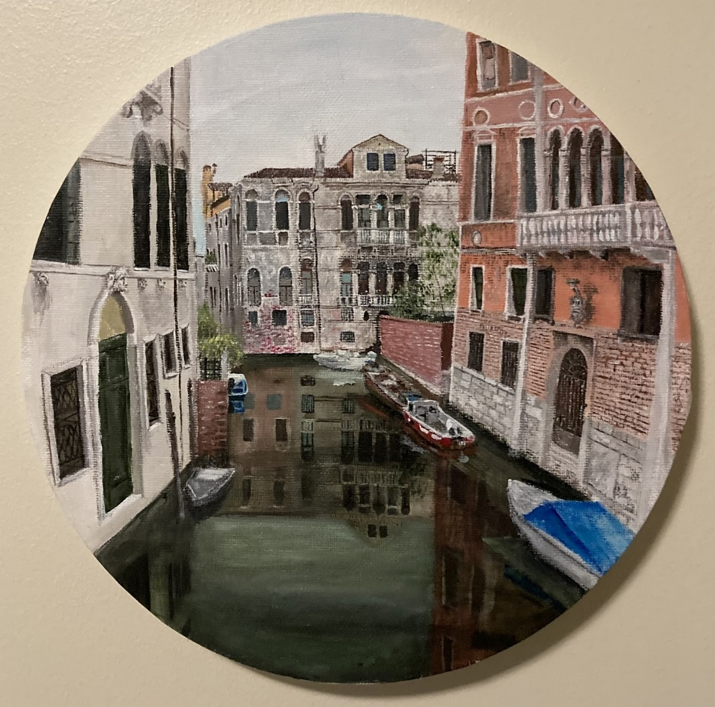

Elizabeth Lonkart

The Box Fan Hums
as a father and daughter
lay back-to-back on a frameless, stained mattress.
The box fan hums, countering the stink of a humid summer night. As creaky springs dig into big and little backs.
The box fan hums on a windowsill devoid of blinds as the yellowy glow of
street lights counter a dark bedroom that belonged to neither father nor
daughter.
The box fan hums under dim streetlight as shadow puppets of little fingers provide a personal theater of entertainment for a sleepless night.
The smell of cigarette smoke and mourning dew meld as little fingers fall, little eyes shut, and box fans continue to hum.

Alyssa Sheriff

The Ballad of a Midwestern Gothic

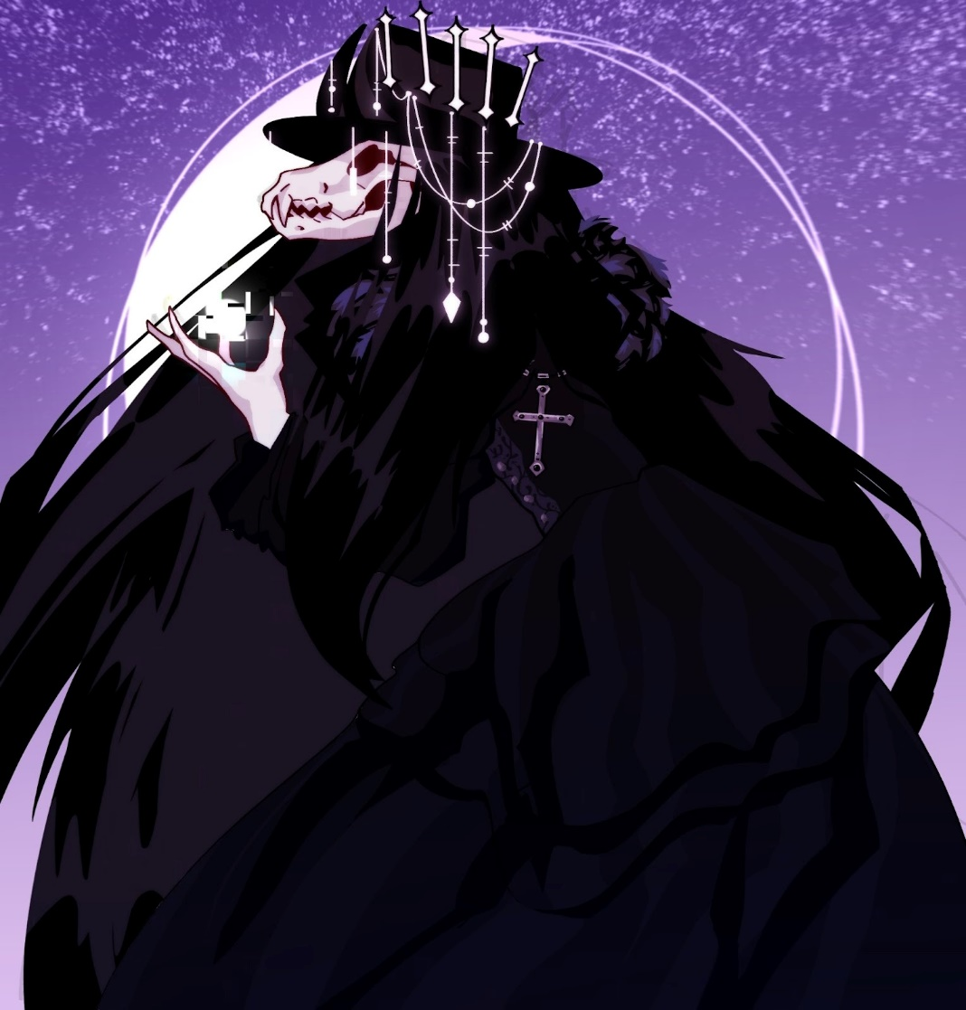

Mallory Reynolds
I’ve Been to Haunted Houses

Where the doorframes are scratched
by kids who walk taller now
Where the floor is still buckled
by the memory of my pap’s footfalls
Where the railing’s wood stain was dissolved
by four generations of hands
Where three Greek letters were stuck to a door
by a boy who will never return home
Where audio tapes were recorded
by a player that sits broken

Where do I haunt?
By what disrepair?

Benjamin Zacharias
Rocks
I was on my way to the florist when it all came back to me. I had the windows of my Honda Accord rolled all the way down with my free hand that wasn’t holding the wheel extended out the window. I was listening to Billie Jean, and I got whiffs of my Harvest Apple air freshener every once in a while. It had been three years since the accident and I was finally starting to get back to normal; or, my new normal. In fact, I was on my way to pick up dried lavender for my sister. I breezed through a yellow light, narrowly missing it turning red, my fingers twitching to the beat.
Almost a third of the way to my destination, a groundhog ran out in front of me. I slowed down a little to avoid hitting it, and a cement mixer pulled out in front of me, driving as slow as possible, of course.
Damn it, I muttered, clenching my fist a bit. The song ended, but I’d put it on repeat so it started up again. After a few minutes of listening to the cement churning, to my luck the truck turned onto the highway. I let my fist open and felt the air hitting it once again.
The pebbles thrown up by the truck began to pelt my open hand. Reflexively, I should’ve closed it, drew my window up and kept driving. But the rocks hitting my hand brought me back. A bit of déjà vu, but I couldn’t recall where the feeling started. Kindergarten playground? No, too far. Drunk bonfire by the lake? No, not it.
As the pebbles continued battering my hands, and I could feel the pointy edges beginning to make their home in my skin, my mind finally decided on which memory it was. Ah, that’s it. When I replayed the memory in my head, this part was never included. It was the prelude, the piece of the story that didn’t matter as much. But it still happened.
That night I’d rested my head in the passenger seat of her truck with my head against the window. She had her hair gathered up in a bun held together with a bobby pin, and the moon reflected off of her eyes. Her window was down, but mine was up because I couldn’t fall asleep with the wind blowing in my ears. I was almost asleep; I could feel the bass drop in the song that was playing reverberate in my lungs.
I heard a sound next to me. I thought maybe she was taking a drag of her cigarette by the way I could tell her mouth pursed. Every night that I fell asleep I seemed to hear this sound. I heard a gasp—or, an attempted one—and at that I startled.
“Wha—”
I shifted in my seat to see what she was doing. Her hands had dropped from the steering wheel. Her eyes were frozen in place, but it was almost a look of calmness. As I snapped to attention, the car began to spin. I reached over to grab the steering wheel, but the tires had lost control. As we spun across the gravel road, I could feel the rocks pounding into my skin.

Kacey Sollenberger

American Television

Two cowboys and two tons of black steel
Blow into town, take a girl home
Or fight another man, knuckle to meat
Whatever gives you hot breath on your neck
Enough to hold you over ‘til the next town
Keep on keepin’ on
Because some things are better without a head
Some things are better burnt up, better pierced straight through the middle
Better them than you
At the edge of a blade or the barrel of a gun, you sit
With a tax-paying angel
And he’s talking with his hands, and his palms are wide enough
To hold the Devil
To cover your forehead, to cover the wound in your side
To pull a pale, gasping fish out of clear water and onto the mud
That thing, inside you?
If it’s not good enough for your father,
It can’t possibly be good enough for God
They made you to worship them,
But kids ain’t supposed to be grateful
And being a father ain’t about being liked
Suck dirt and die, go down swingin’, do it right with a smile, save the day, get the girl, take the bullet, fall into bed every night like another step will kill you
Take your brother outside
And put a gun to the nape of his neck
The dead are walking in Sioux Falls
But you’ve been walking this whole time

Jean Stitchfield

This is Fine, probably: A Tale of An Optimistic Navigator

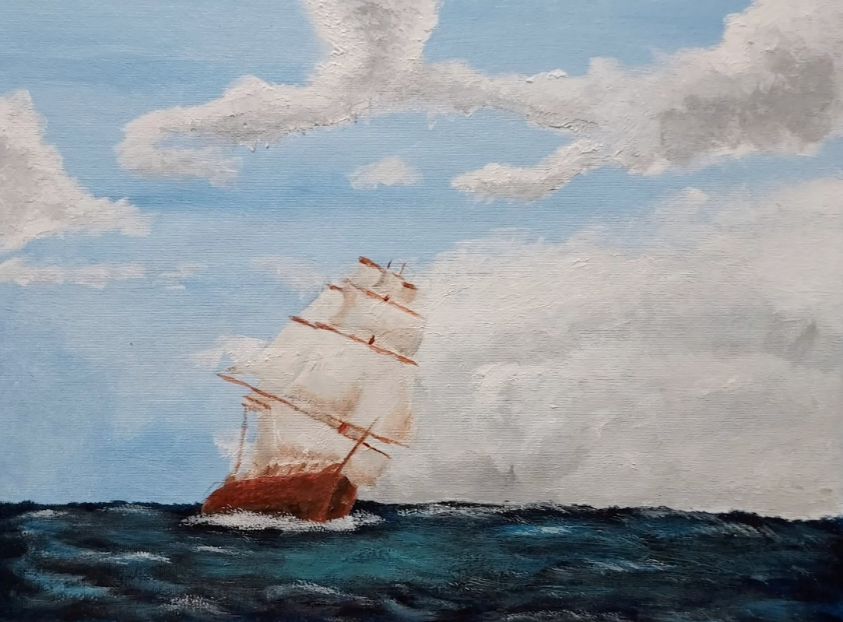

Hannah Campbell

I would like to…

I would like to break something.

To snap colored pencils when I get too upset
Smash my clay sculptures when they don’t look perfect

Rip up carpets and feel stiff boards under my feet
Punch through walls because I never did before

Crack glass cups because they burned my hand
Destroy plastic cups because they made my hands too cold

Build a house only to
Push it down because I didn’t want it
facing towards the sun

Tear out a few pieces of a journal
To start a
fresh
clean
book

I would like to break a few eggs to start making an omelet

I would like to break something.

Kaylee Will

On My Way

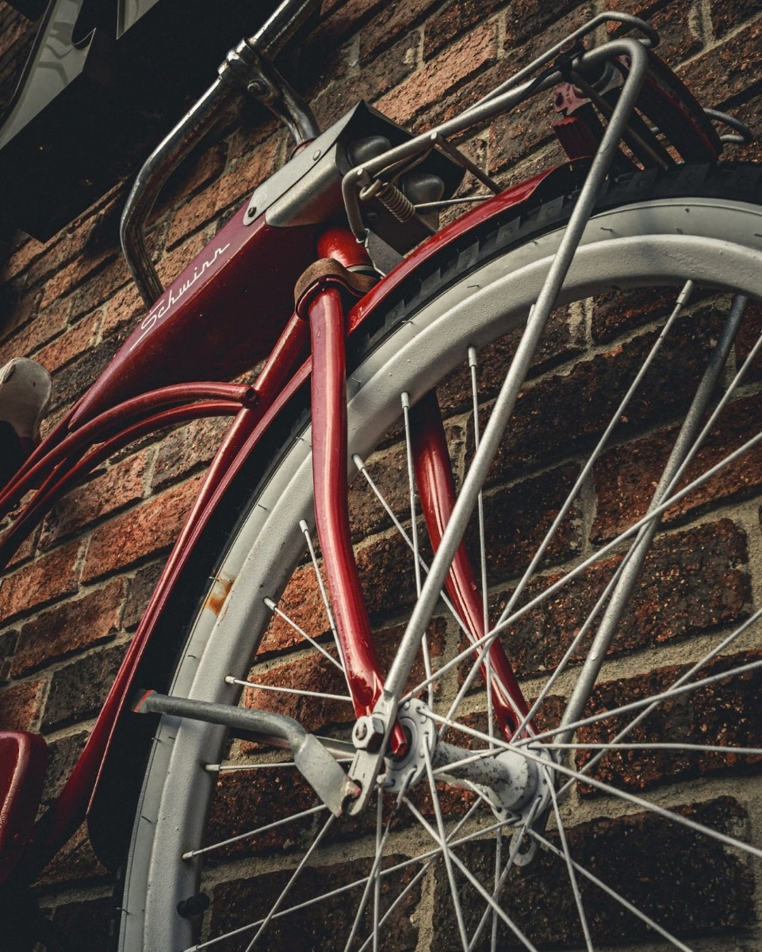

Noah Guillaume
An Allegory of Catholic Faith
I ask you, fair maiden wrapped in the vibrant blue cloth
with your protected foot perched perfectly
on the world beneath you
when you look up at heaven
do you see Jesus,
who walked among humans
the same humans who have sinned
He who fed the harlots
and lifted the disabled
who was killed and took the words
Be kind to one another, with him
or do you only see
your own blissful salvation
ignorant to the bleeding evil
that you crushed with stone
the same evil that Yeshua himself
wrapped tightly in his arms
that was perhaps not entirely all that evil
to begin with
Emmett O’Bell
The Secrets of the Mountains
They never should’ve gone camping.
Tori sat in the police station with Gavin and Ana on either side of her, the plush chairs having grown uncomfortable as time passed. Officers rushed about the bullpen, carrying manilla folders and mugs of coffee with them as they shot from room to room, desk to filing cabinet to computer. They’d been there for an hour, waiting anxiously for Chief Connelly to return with news. At this point, they didn’t care if it was good or bad, they just wanted some sort of update.
0“Do you think . . . I mean, he can’t be . . . can he?” Gavin’s eyes were glossed over, much like how a traumatized war veteran’s did when they remembered their deployment. His one hand was gripped tightly in Tori’s, knuckled white and skin cold as ice, while the other fumbled with his dead phone. The screen was covered in cracks and dirt, one of the shards having slit his thumb at one point, but he didn’t seem to care. “Can he?”
On her other side, Ana rubbed violently at her eyes, the skin around them puffy and red from the hours spent crying. When she spoke, her voice was thick and wet. “He just had to break rule number one, didn’t he? God, I should’ve known.”
Tori didn’t get the chance to comfort either of her companions, not like she would know what to say anyways, as heavy footsteps approached them from the left. The trio looked up, shoulders sagging at the emotionless face of Chief Connelly. His uniform was one size too small, the buttons of his shirt holding on for dear life, and the black fabric of his pants had faded around the knees from years of crouching low to inspect forest floors and animal tracks.
He needs to get a new pair of pants, Tori thought absently, trying her hardest not to spiral at the fact that Connelly had returned alone. And maybe some jewelry cleaner. His badge isn’t looking all that shiny these days.
The leather of the chief’s chair squeaked as he sat down before the kids, his elbows coming to rest on his knees as he clasped his weathered hands together. There was a look of knowing in his eyes, and the wrinkles on his face seemed to have deepened since they last saw him. Whatever he’d found in the woods . . .
“Alright kids. I have some good news, and some bad news.” The trio seemed to perk up at the mention of something good. “Which would you like to hear first?”
“The good!” Ana nearly cut him off with her fast response. Her shoulders were rigid, and her eyes were wide, locked on Connelly in desperation. “Please, God, tell us the good.”
Connelly nodded and leaned back in his chair. “We found Joseph’s phone and a couple of tracks that might belong to him. Forensics is looking into it as we speak.”
Tori released a breath. That’s good. The phone and footsteps could tell them where Joseph had gone, right?
Gavin’s grip on her hand grew tighter. “And . . . and the bad?”
“The bad . . .” The old chief sighed heavily. “They were found by Wilson’s path.”
Tori felt the blood drain from her face. “Wilson’s path . . . but we weren’t anywhere near there! No one sane goes near there!”
How was it possible for Joseph to be near Wilson’s path when they were camping on the opposite side of the mountain? It’d take at least three hours to get there on foot.
“I’m well aware, Miss. Richards. Which is why I need the three of you to be honest with me.” Connelly met their eyes one by one, his lips pursed in a thin line. “What exactly happened last night?”
Tori could feel the eyes of Gavin and Ana burning into her, their gazes like molten steel. It should have been Ana telling the story. After all, Joseph was her boyfriend. But Tori had been the last one to see him before . . .
She closed her eyes, sucked in a deep breath, and tried her best to think back to the night before. “It all started when we decided to go camping.”
24 Hours Earlier . . .
“I’ve had about enough of these fucking mosquitos!”
The other three ignored Joseph’s complaints. He’d been at it for two hours now. The only thing that would make them react at this point was if he was dying or falling off a cliff or spontaneously combusting. And since neither of those things were currently possible, they continued their trek to the campsite.
“We brought bug spray, Joe. It’s in Gavin’s pack.” Tori nodded to her boyfriend who was keeping pace at her side. Before leaving the car at the base of the trail, they’d split their necessities between the four bags, hoping to lighten the load a bit. Gavin’s pack had all things medical, which included a massive can of bug spray. “Spray some on yourself and shut up. We only have a mile left.”
Joseph groaned. “A mile? Why couldn’t we go to Vegas or something for spring break? Why did we choose camping of all things?”
Ana, having enough of her boyfriend’s whining, pivoted to face him with her arms crossed. “One, because none of us have the money for Vegas. Two, because no one needs to fuel your gambling issues. And three, because camping is nice and all of us need the time away from society after thee finals week we all had.”
Tori and Gavin had to purse their lips to keep from laughing at the saddened puppy eyes Joseph was giving his girlfriend. Petty arguments like this weren’t uncommon between the two, but they were always funny to witness. “Don’t give me that look, Joseph Armstrong Samsel! Get the bug spray and woman up!”
With a few grumbled curses, Joseph did as he was told, and they continued up the mountain.
It wasn’t more than five minutes later that Joseph began talking again. “So, what’s with this campsite anyways? Why this specific one?”
Tori shrugged. “It’s the one Ana and I would always come to when we were kids. Our Nana would take us every summer, and we’d sit around the fire, telling spooky stories and eating a shit ton of marshmallows.”
It’d been five years since the sisters had been to the campsite, and five years since their Nana passed from heart failure. Neither was quite sure of how returning would make them feel, but they didn’t want to forget the spot. That would be like forgetting their Nana.
“Stories?” Gavin asked, pausing to get the spray from his bag. He passed it to Joe, who stepped away to use it. “What kind of stories? Are we talking spooky-but-funny stories or shit-your-pants-from-fear stories?”
Ana shrugged. “A little bit of both, depending on Nana’s mood.” Joe took his place at Ana’s side once more, handing back the spray. “But the stories always involved someone breaking the rules of the mountains and getting in trouble for it.”
The boys frowned, sharing a look of confusion. Gavin grabbed Tori’s hand, stopping her from walking too far ahead. “What rules? You never said anything about rules.”
The sisters turned to face their boyfriends. Tori was certain she and Ana had gone over the rules of the Appalachian’s during the car ride, but maybe not. A lot had been talked about on that two-hour drive.
“We’ll walk and talk, okay? We don’t want to be stuck setting up camp when it’s dark.” Ana took Joe’s hand and the sisters started walking again, their boyfriends trailing behind them with much less enthusiasm than before. “Anyone who’s ever grown up in the mountains knows there are certain things you do and don’t do. It’s survival and superstition mixed together, but no one questions it.”
Tori nodded. “There’re only three main ones you have to follow at all times. One, never whistle at night. It’s believed that doing so attracts spirits.” The boys grew pale at the mention of the paranormal. “Two, never go into the woods at night alone. The trees have a habit of messing with people. And three, if you hear or see things in the woods at night, never go investigating.”
Gavin nodded quickly. “Those all seem like easy rules to follow.”
Joe, however, seemed to think the opposite. “What, so we’re just supposed to ignore potential ax-murderers because the trees said so?” He scoffed, rolling his eyes. “Yeah, no. If there’s something out there at night, I’m doing something about it. I’m not about to die while camping.”
Ana shot her boyfriend a stern look. “You’ll be doing no such thing, Joseph! Have you never seen a horror movie? Don’t be the stupid white boy who goes investigating! I will not have my boyfriend die like a nineties horror movie side character!”
The rest of the trip was spent in silence after that. No one really wanted to speak. It was obvious that Joseph was still skeptical about it all, and that Ana was furious with him for his nonchalance about basic survival. So instead of joking around like Tori and Gavin usually did when the couple had their spats, they remained quiet, hoping that the two would make up before things got awkward while sharing the tent that night.
By the time they reached the site, the sun was beginning to turn the sky a vibrant orange and pink, stars just peeking out from behind the clouds. The four teens dropped their bags in the center of the site, Joseph practically collapsing onto his back with a groan.
“Next time we go camping, it’s gonna be in our backyard. No way am I hiking up that mountain again!” he complained.
Tori kicked his foot. “Shut up and help us set everything up. We can relax once the tent is pitched and the fire is started for dinner tonight.”
All she got in return was a grunt and a muttered curse that she opted to ignore. Instead, she began helping Gavin with the tent, leaving Ana and Joe with the job of collecting firewood.
“Ever pitched a tent before?” she asked Gavin.
Her boyfriend grinned. “You’re looking at an Eagle Scout, babe. Of course I’ve pitched a tent.” He then looked at the tangle of poles and canvas. “But I might need some help with this one.”
“Of course you will.”
“Oh, come on! This tent has way too many poles!”
The couple worked together in silence for roughly five minutes before Joseph—who had gone searching for wood earlier with Ana—came running into the clearing like his ass was on fire. He was white as a sheet, his eyes wide and arms flailing around while Ana trailed behind him, looking just as spooked. But when her eyes locked with Tori’s, she realized it was for different reasons.
“What the fuck happened?” Gavin asked as they stood. Joseph stumbled to a stop in front of them, breathing hard. “Did you get chased by a bear or something?”
“No!” The shout was so abrupt that it sent birds scattering from their perches in the trees. “Foot! Big footprint! Big fucking footprint!”
Tori’s eyes went wide. Oh, shit! That’s why Ana looked ready to pass out!
“I’m sorry. Did you just say big footprint?” Gavin blinked rapidly, almost like he’d been smacked between the eyes. “Like bigfoot? Sasquatch?”
Joe looked like someone had slapped him. “Holy shit! It’s a bigfoot footprint!” He whipped around to face Ana, who had dropped the pile of wood she was holding earlier. “It’s a bigfoot footprint! I told you there was something off about it! No one has a foot that big!”
Tori rushed to come up with an explanation. “It’s probably nothing! Just a joke that other campers are pulling on us. I’d ignore it, honestly.”
Joe shook his head. “There’s no way a group of campers could’ve made that! It’s perfectly shaped! I mean, it’s so big that I could see the lines from the skin in the dirt!” His eyes were bugging out, like those alien-believers from Sci-Fi movies. All he was missing was a tin foil hat. “You’ve gotta come see it! Come on!”
Ana looked like she’d already given up, her pleading eyes locked on her sister as if to say, Do something!
But Tori had already tried to deter Joe. It was clear that no matter what she said, he would drag the four of them back to where this footprint was and make sure they all saw it. So, with a huff of annoyance, Tori took Gavin’s hand and followed a very excited Joe with Ana trailing behind.
The walk wasn’t long, but Tori’s mind was a whirlwind of thoughts. What would happen if Gavin saw the print? Would he react like Joe? Would she and Ana have to perform damage control? It was times like this when Tori wished her Nana was still there, being just a call away and ready to fix any problem the sisters had. But their Nana was gone, so it was up to Tori and Ana to fix this.
“Here! Right here! You see that!”
Gavin frowned. “See what?”
Joe looked at him like he was an idiot. “’See what?’ Gavin, it’s right there! The big— where’d it go?”
The patch of dirt that Joe had been pointing to was just that, a patch of dirt. Rocks were scattered with fallen leaves and twigs, but the dirt was smooth and unbothered. No footprint, no indentations of any kind.
“So . . . the footprint?” Tori tried to fight back her grin. The mountains had done it again. “You sure it was here?”
Joe’s brows were furrowed. “It was right here! I swear I’m no lying!” He looked to Ana. “You saw it, too, right?”
Ana gave him an apologetic smile and shrugged. “Sorry, babe. Maybe . . . I mean, we’ve been up for a while, and the walk here was pretty tiring. I think you just saw what you wanted to.” She reached for his hand, locking their fingers together and tugging him to her side. “Come on, let’s get back to camp and get the fire started. After some food and good sleep, you’ll be all good.”
Joe looked between the forest floor and Ana before sighing in defeat. “I could’ve sworn I saw a bigfoot track.”
“I know, babe. I know.” As Ana and Joe moved past, she and Tori locked eyes, a mutual understanding passing through—whatever happened tonight, the mountains would make sure it stayed quiet.
***
That night, after hot dogs and s’mores and enough spooky stories to make one’s skin crawl, Tori found herself cuddled up to Gavin in their tent, Ana and Joe on the other side. Every so often they’d hear the quiet chittering of a squirrel or the hoot of an owl beneath the gentle mountain breeze, lulling them to sleep.
There was no telling how much time passed before Tori woke to rustling. Through blurry eyes, she could just make out the silhouette of Joe slipping between the tent flaps, his shoes on and phone in hand. She glanced at their sleeping space, finding Ana still asleep.
Tori slipped out of Gavin’s hold, her gut twisting at the thought of Joe sneaking off into the night by himself. He knew the rules. Why was he breaking them?
She slipped her shoes on and grabbed her phone, quietly stepping out of the tent. The moon was high in the sky, stars twinkling against the black canvas of the night. The air still smelled like smoke from the fire mixed with pine and the natural air of the mountains.
Joe was a few feet in front of her, his flashlight on and aimed towards the trees.
“Joe?” He jumped like a startled cat, whipping around until the flashlight hit her eyes. “What are you doing? Why are you out here?”
Once the light was moved, she could see that something wasn’t right. Joe’s eyes were crazed once more, open wide and a little bloodshot like he hadn’t slept yet that night. “I heard something out there! It’s gotta be him!”
Tori felt her heart drop to her stomach. “What do you mean?”
“Bigfoot! He’s out there!” He gestured to the trees with his one arm. “I didn’t imagine those prints! He’s real and he’s out there right now!”
She sighed and dragged a hand down her face in frustration. “Look, Joe, I get that you want some big adventure or some shit, but bigfoot isn’t real, okay? You want to know what’s real in these mountains? Bears! Cougars! Random cliffs that you can fall off! Get back in the tent before you do something stupid.”
Joe shook his head. “No. I’m right about this. I don’t care what you or Ana say— you’re probably trying to hide it from me or something! He’s out there right now and I’m gonna find him!”
Tori bit back a groan. He had officially lost his mind! “Is this about money? Are you hoping to get some big fucking fortune from ‘capturing bigfoot’? Is that what this is?” Joe nodded adamantly. “That’s not worth dying, you idiot! No amount of money is gonna fix the debt you’re in, alright? Get a therapist, go to an anonymous group! I don’t care! Just don’t go wandering off after some mythical being in hopes of becoming rich! Get back in the tent with Ana and sleep!”
“Shut up!” Spit flew from his lips as he flung his arms about. “This can fix it all! One picture, Tori—just one picture! I’ll be famous! All my debts will be gone!”
“Or you’ll just gamble the rest of it off and leave yourself in more trouble!” Their voices were echoing off the trees now, and Tori was surprised that neither Gavin nor Ana had woken up yet. “Just—Ana loves you, okay? Don’t do this.”
A sudden crash coming from the woods filled the air, and Tori realized that nothing she said now could change his mind. Whatever had made that noise was too big to be a bear or a cougar. And the maniac fascination in Joe’s eyes only proved that fact. There was no coming back for him.
“I’m getting that picture, Tori. And I’m getting that money.” Joe started for the trees again, moving much quicker than he had before. “I’ll be back before the sun comes up, richer than anyone in this whole fucking world!”
Tori tried to go after him, her flashlight on as she followed his footsteps through the trees. But he was faster, and much more determined than she was. It didn’t take long for her to lose sight of him completely, his figure disappearing into the darkness of the Appalachian wilderness. Her heart was pounding in her chest, mind racing as she tried to figure out what to do.
She collapsed onto the forest floor, tugging at her hair in frustration. “Nana, God, I wish you were here! You’d slap sense into that boy, I know it.” She laughed weakly. “What do I do now, huh? What am I supposed to tell Gavin and Ana when they wake up, and Joe isn’t in the tent with us?”
Tori waited for a moment, praying that she’d hear Nana’s voice, but all she got in return was the howling of the wind between the branches. So, she picked herself up, dusted her pants off, and made for the campsite, hoping that the mountains would guide Joe back to safety.
Because if Joe did find what he was looking for, and if Joe did get that picture . . . well, there was a reason that so many campers went missing in the mountains. The Appalachians always knew how to keep secrets, even if it meant silencing the problem themselves.

Alex Heckman

How to find your special someone
A pink neon sign flashes
“Singles welcome!” and beats that rattle
Through my heart emit from inside
Curiosity takes over so I take a peek
Not much can be seen from the grimy windows
So I must crack the door open and glance
Bodies everywhere
Looking so close but never actually touching
The men are bored and the women are
Uncomfortable
The furniture is broken so everyone
Must stand
And the DJ seems to be the only one having fun
A girl shaking like a chihuahua shoves her way past
I watch the excited glow dim and fade
As she takes in the scenery and
Goes to the bar to order rum and coke
I have seen enough so I go to close the door
The judgy stares and pitiful looks are better
Than whatever that hellhole is
I shut off my phone and leave my apartment
Going to see what my friends are doin

Kleio Mae

Untitled

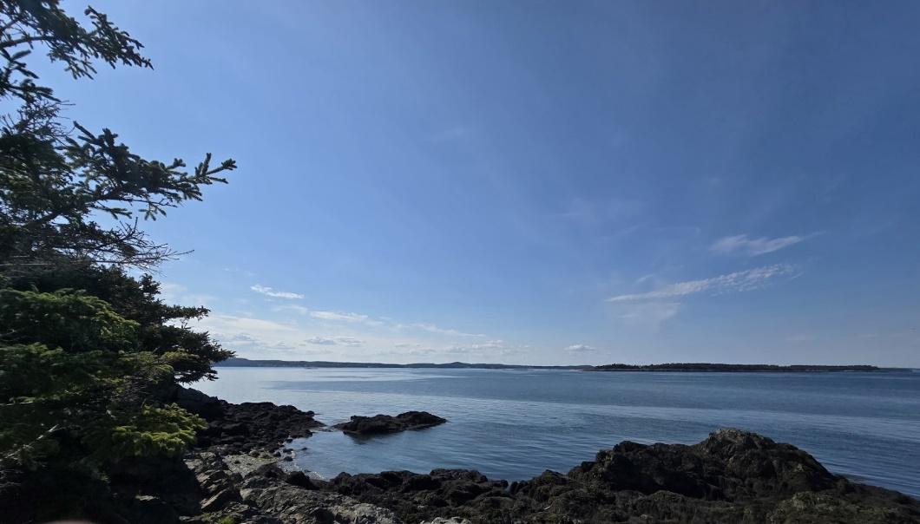

Gretchen Steel

Animal
I used to be all skin but now
I’m all animal –
call me
bear, jack rabbit,
all teeth and fur
struggle and sinew and –
well now, what do we have here?
a bit of skin under all that fur
under all that mascara
under all that jewelry –

I used to be all skin but now But,
I hide it better – her eyes are a bit too jagged,
call me a jackrabbit’s red-eyed stare --
vicious, feral, her snarl’s a bit too fanged,
all teeth and fur a bit too wide and grizzly --
blood and veins and – Now I’m just all animal,
okay, well she tried her best wild but caged
didn’t she? struggle and sinew and –
used to be all skin and then my my, what big eyes you have
went on out and covered up. darlin’
How thoughtful. and my, what a beautiful set of

oh – so you really are just skin under
all that?
coulda fooled me
darlin’
yer all skin and maybe
some animal
eyes wide and wild
grimace all blood and struggle
a grin grinning to bear – it –

well, darlin’
just who do you think you are?

Jenny Russell

Untitled

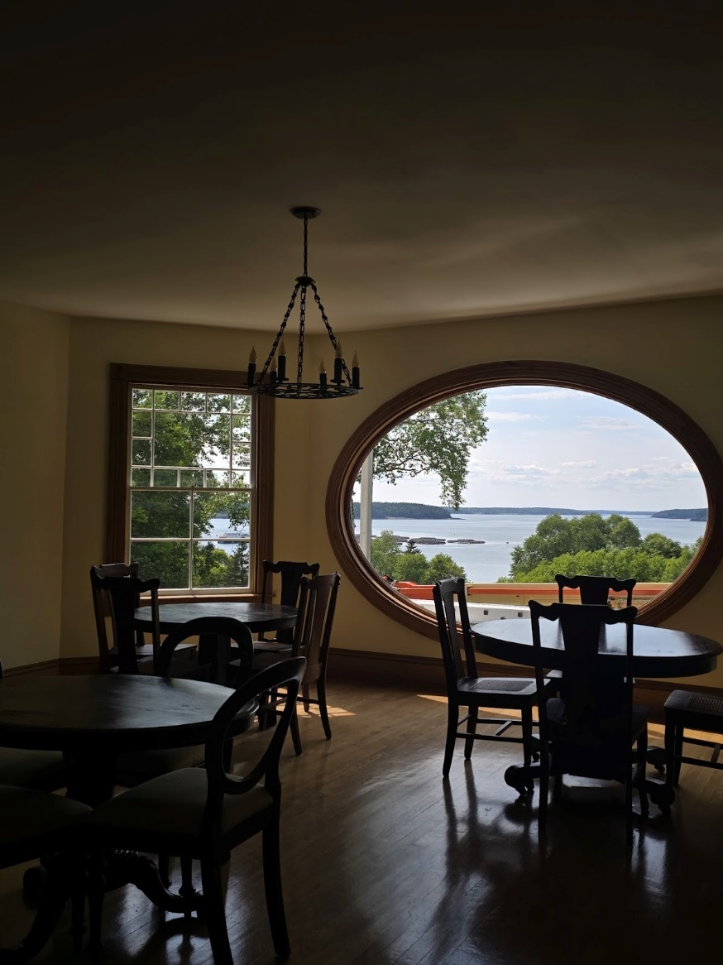

Gretchen Steel
sowing dreams

a cluster of wishes
rests in the palm of my hand.
the soft fur shed
from the lion’s mane.
blow gently and spread
these fragmented dreams
across barren fields.
pray that these seeds
take root in the hearts
of the children who find them.
pray that these children
grasp dreams tightly against
their beating chests.
pray that they hold fast the
hope bestowed to them.
pray that they do not return to
those desolate fields.

Reed Vollrath
The Park is so Cold After Dark
Third Place | Dziennik-Russell Prize of Excellence

I’m sitting, I know that much.
It’s dark. I know that, too.
I could name one-hundred places, describe it all in detail, and it wouldn’t change a single thing.
They aren’t here.
The sun set at some point, fading any light from the day and shading everything with gray and dark blue. I fidget, pressing my fingertips against the cold mental beneath me, readjusting my body. My feet kick almost involuntarily, anxious. A few pebbles let loose from the worn concrete.
My shoes are worn, loose threads jutting in each direction. They’ve always been my favorite pair of hand-me-downs, bought years before my feet would be big enough for them. They don’t protect my feet like they should, I know that. Not that it matters right now.
They aren’t here.
A gruff looking man with a golden police badge pats my shoulder gently as he drops a small black backpack beside me on the bench. It’s metal buckle clangs gently against the metal, the various enamel pins clatter against each other. It’s mine, I think. No one else could possibly claim it. The zipper sticks as I pull on it, so I reach one hand in and begin pulling its contents out like I’m reaching into a jar blindfolded. A blue, stained hoodie in a plastic bag, a small notebook, and a small, hand painted keychain.
They aren’t here.
No, these things aren’t mine. They couldn’t be. It’s all hers, and she isn’t here to collect any of it. What’s hers is mine.
What’s yours is mine, we used to sing as we dug through each other’s closets. None of this is making any sense. A small pang in my heart, a tightness in my chest, tells me it will never make sense.
“Are you next of kin?” the officer asks, and I realize suddenly that he never left my side. He pats my shoulder again, as if checking to make sure I’m still conscious.
“She was my sister,” I say softly. My breath catches on what I have just said. She was my sister. Was.
They aren’t here.
The longer I sit here the more I can feel the cold from the metal seeping through my pants and onto my skin. I feel naked, despite the layers meant to protect me from the chilly, February air. I wrap my arms around myself, watching as the officer nods, lips pressed into a fine line. His eyebrows scrunch together; he scratches at the stubble on his chin.
“And your parents?” he adds after a moment of silence, looking me up and down, sizing me up.
They aren’t here.
“They should be here any minute,” I insist, nodding my head as if to convince myself it’s true. “I left a dozen messages,” I add.
My eyes burn, feeling heavy. I blink slowly under their weight, reaching a hand up to rub at my eyelids. My vision is blurred when I open my eyes again, and they are looking at the fuzzy figure of the officer. He stands directly in front of me, hands on his hips. A gentle tap tapping echoes off the concrete floor, amplified by the quiet of the night air, a metronome waiting for an instrument to accompany it.
I’m outside, I think. The bench beneath me is lit only by the streetlamp above it. From this angle I imagine I look like the suspect being interrogated by the restless officer. I wonder for a moment if, when his shift is over, he’ll go home and forget about the events of tonight, if he’ll forget these long, uncomfortable moments, waiting for two individuals we both know are not coming.
It’s late, and for the first time I feel aware enough to take stock: I’m fifteen, my sister is dead, has died, has been killed, and my parents aren’t here.

Jenny Russell

Eggs
The eggs don’t hatch.
They must be glad she came for them. She’d watched the nest for six days before she took them. No mother came, no mother left.
She warms the eggs in her hands, cradling them like small, wet things and blowing balmy air over their cool shells. She is better than any bird.
She walks them through her empty house, shows them the coffeemaker. She tells them they can’t have coffee until they’re older. She watches Wheel of Fortune with the eggs tucked into the hollows of her lap, but she keeps her eyes on them. They are too small to look away from.
The first hairline crack comes. She waits for a beak. She waits, and sits, and stares, and waits. The egg does not hatch.
The smell comes a few days later. She tucks her nose close to her eldest egg, breathes in the cloying rot until she’s dizzy with it. Embryonic fluid leaks, thin and gray. It coats her fingers, and she does not wash them.
She peels back the shell in careful pieces, and finds a small, wet thing. Curled up, pink, unfeathered, pooled in yellow. She has never seen such unopened eyes.
She leaves it in the kitchen, damp and putrid under the sunlight streaming in. She sleeps with the rest of her eggs curled into her breast, and she is so warm, and she is better than any bird.
She wakes to wetness, to yellow, to crushed shells, and a clump of small, wet
things.

Jean Stitchfield

The Perfect Autumn Day: Bug Crawling on a Miniature Daisy

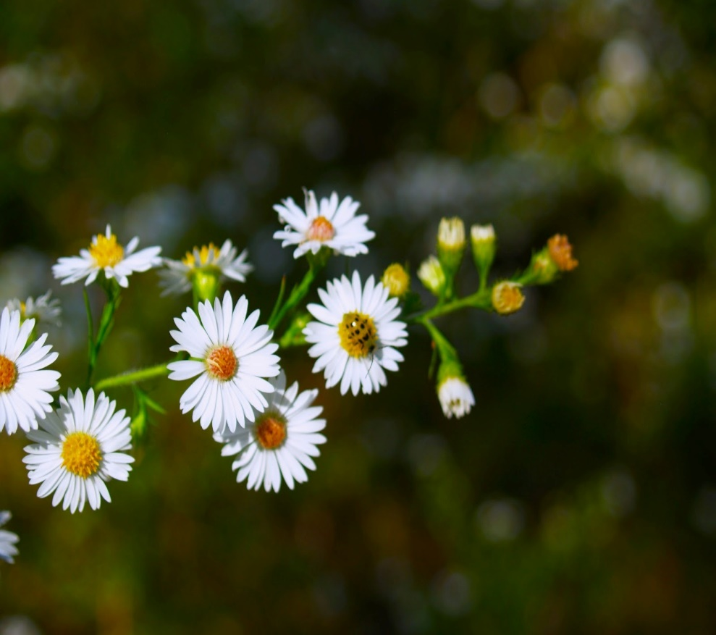

Anna Eastman

“Femina”
Shame and fear
Old teachings claw at my brain
I don’t know myself
My body never belonged to me

My body could rebel
The new virgin Mary
I could inflate like a balloon
And punch it flat to free myself

Would it be disemboweling
If I let it happen willingly?
Can I cut out my uterus
Or leave my eggs to the crows?

I cry
I panic
No this body isn’t mine
No one wants me to fix it

My mother weeps at the hospital
When I decide to make myself well
I can’t help but smile when it’s done
When my body no longer rebels against me.

I am now free
I am now kinder to myself
I no longer reel from those tortuous thoughts
My tubes look best on a lab table

I was joyfully made new.

Katie Waite

Self Portrait

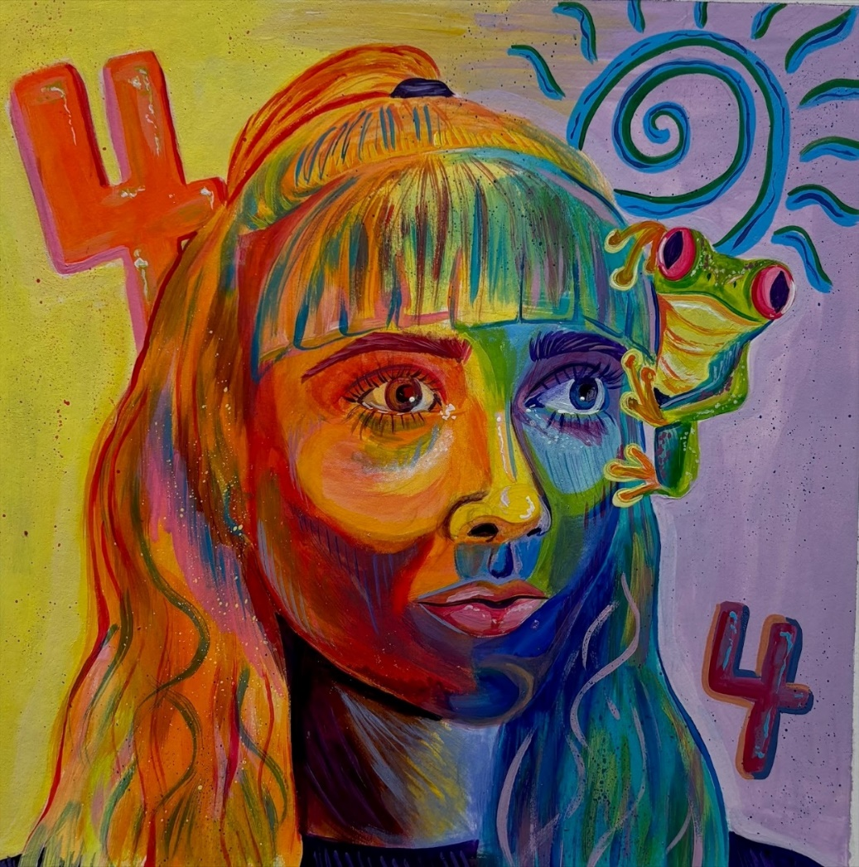

Rose Emenheiser
The Colors of My Heart
Green, the color of his eyes.
Half lidded with love and lust,
always crinkled in delight.

Brown, the color of his hair.
Tousled from my hands,
silky to the touch.

Pink, the color of his lips.
Swollen from late nights,
slightly chapped from kisses.

Tan, the color of his skin.
Smooth and clear of any blemishes,
pressed against my breast.

Red, the color of his heart.
Beating with anticipation,
racing at the thought of us.

Alcinda Burchill
The Gallows

The one thing that everyone knew about Lavinia was that she could be found at the docks each evening that the crowds gathered by the gallows. On these evenings, an hour or so before the sun settled behind the village, Lavinia usually sat on the shore away from the other people and their curious minds. Tiny pieces of shell jabbed into her feet as she slid them back and forth over the sand, but she didn’t stop. This afternoon, she had arrived early, as she usually did. She hated entering a crowd; the animated waving hands, men chuckling and talking about the same old things, not moving an inch to make room for passersby. With the twig in her hand, Lavinia drew figures in the sand until she heard the clanging coming from several yards away.
Just inside of her peripheral, Lavinia could see a line of people. The men, hands and feet bound in chains, crossed the bridge. The crowd surrounding her began to notice as well, and their casual chatting turned into taunts. Without lifting her eyes Lavinia already knew the routine. The men filed into the tavern one by one with the door closing behind them. As quickly as the taunting had begun, it ceased. Though she’d never been inside the tavern while the ritual took place, Lavinia had heard enough stories to picture it in her mind. She could see the men crowding into the tavern, the marshal making sure every last one of them was inside, before slamming the wooden door shut. The men lined up against the bar stools, although no one pulled them out for them to sit on. The taverner pulled out as many glasses as there were men and filled each about halfway with ale. Stopping by each man, the marshal allowed each to have their final taste of any earthly substance.

Kacey Sollenberger

how a tiger brushes her teeth

simple things can still be hard things
for instance
standing in front of a mirror
looking at yourself for a minute and then
get tired of that so you
look down
that ceramic bowl lined with the past spit
from maybe like 20 people or more
and you think someone that is dead now
has spit in this sink
and you glance at the almost empty tube
and you think
i have to buy more toothpaste
and it takes you a few more moments
to actually begin brushing your teeth
because you're stalling for
some fucking reason
and then suddenly behind you in the mirror
is your mother
and your reflection is smaller now
six years old or so
back when she would still brush your teeth
for you
back when she was teaching you
everything you needed to know
and you remember how she taught you
to growl like a tiger to get your front teeth
so you do
for at least two minutes
as you brush you feel her fingers
on your scalp and neck
you hear her humming and
sometimes she growls with you
mother tiger and son
she pulls your hair out of your face for you
and you spit in the sink
and when you look up your mother
in the mirror is gone
it’s just you big again and
you feel a bit better as the water
from the faucet drags the froth from your mouth
down the drain with it
Emmett O’Bell

Cat Eye

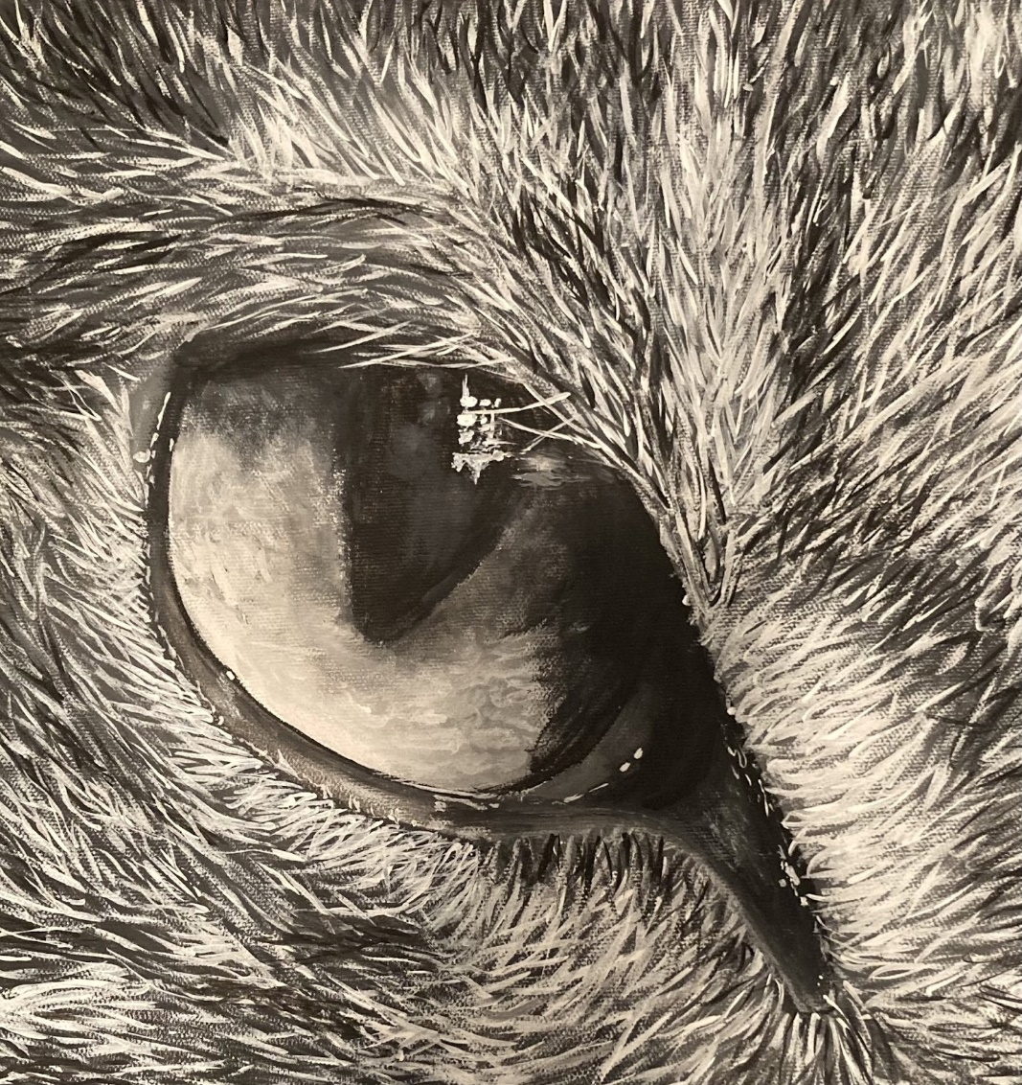

Elizabeth Lonkart

i, hedonist,

oh, just one more jolt, love,
breathe static into my lungs,
drip liquor onto my thighs,
remind me how great you are,

like old times, love,
disrupt my airway with
your lips, 11 am on tuesday,
at church on sunday,
a familiar kiss, a hint of
pine, all natural,

oh, love, knead me into the sheets,
you’re such a turn on, oh,
turn on the radio, love, quick,
tune into FM, fuck me,
max volume, sweet melody,

oh, love, it feels better
when you breathe it in my ear,
oh, you, electricity in
my chest, oh, my love,
my hunger, i eat only
for you, of you,
i am you, i belong to,

oh, love, yank out my teeth,
keep them safe, for
the memories,
oh, sentimental lover,
supernova lover,
explode with me,
oh,
oh,
oh,
!

Daniel Wintersgil

Serenity

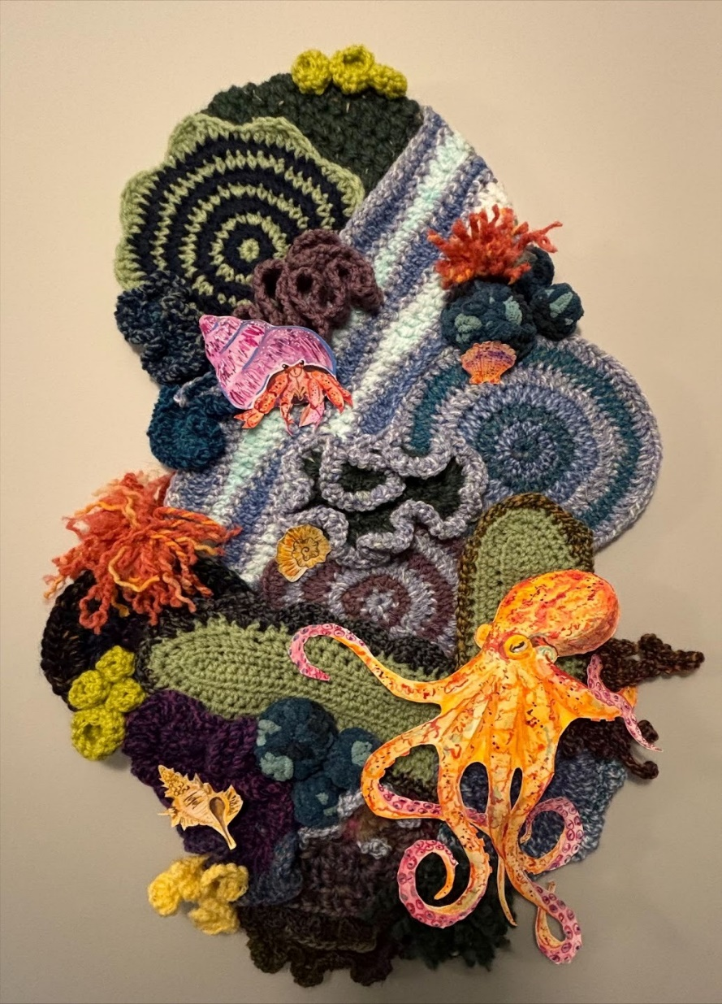

Rose Emenheiser
My Time in New York

Today,
I am swallowed whole by the city
And I welcome it
With its skyscrapers like daggers
Which pierce the skyline
As they glint under the pitch black of evening
Today,
I am insignificant
But strangely,
Alive
Invigorated, almost.
Today
I am
Swallowed
Whole.

Ava Hawes

The Boar

The boy had never held a real iron in his hand. Ten years is too young to learn to hold a pistol. He’d shot a goose last year with a small shotgun. He’d used his father’s rifle to kill a boar this spring. A boar—that’s what was in front of him—it helped to imagine the fat, grimy, sweat-stained man in the parlor as the swine he was at heart.
The boar was standing over the boy’s father, his boots wading in the pool of blood that he’d sprung by plunging a knife into the father’s side. He reached over to the boy’s mother and with his bloody hand ripped down the front of her white dress, exposing her naked body to him.
The boy drew in his breath and looked down the pistol’s sights to the back of the man’s left shoulder. He brought the invisible point extending from the sights down and center more, just on the other side of the boar’s breast. He held for a second, even while the porcine man reached for his mother, and squeezed the trigger like he would an orange.
Deaf, the boy raced into the room as the animal fell onto his mother. He stopped at her side and sloughed off the wet, leaking sack of blood and meat that heaved out a last dirty breath. He wanted to embrace, to comfort his mother. He wanted to weep atop his father. Yet he cried for the boar, the beast, the man he had killed. He mourned the boar and the youth who died along with him.

Benjamin Zacharias

Juice from an orange
is on the table.
It is sticky and ignorant
and i’m daydreaming
In poetry class about
sitting in my car and
Eating another one
in silence.
The juice, dribbling down my chin;
naughty and careless,

and I don’t have a napkin.

Eloise Brewsy

Clawing at thin air

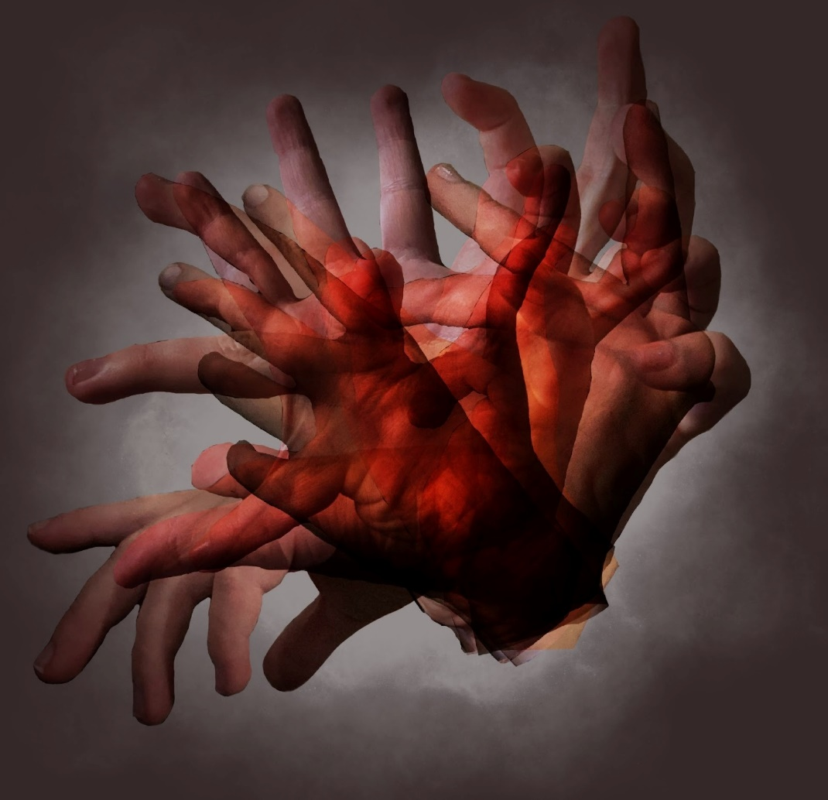

Hannah Campbell

Bloodletting

i heard that they
used to cure disease
by piercing the body
and letting the blood
pour freely
believing the affliction
would exit alongside it
or similarly
placing leeches on
the body in order to
extract the illness
from within
nourishing one body
while curing another
so i must ask if there
are similar remedies
conducted through
tears rather than blood
if a syringe were to pierce
my tear ducts would sorrow
be withdrawn as well
would i be able to place
it upon a slide and study
it beneath a microscope
would i be able to identify
its etiology and find
a more effective treatment

Reed Vollrath

Untitled

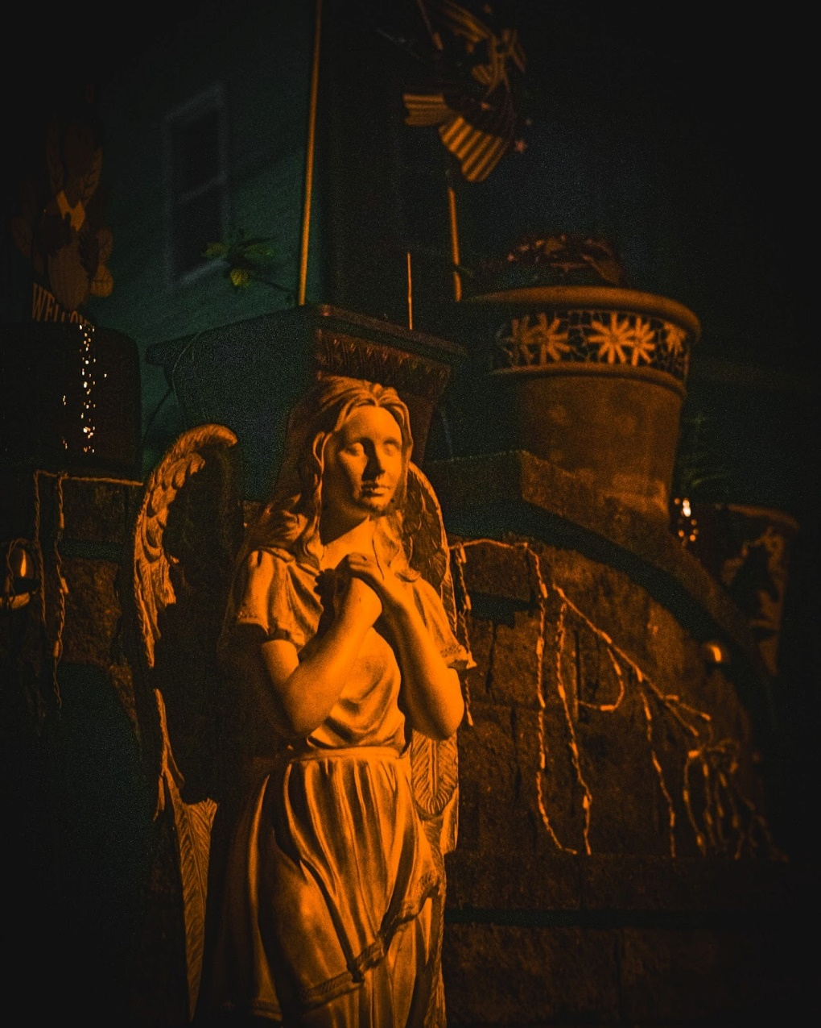

Noah Guillaume
I Hear the Birds

I understand what the birds say.
I sit outside and look up to the sky,
Listening to their sing-songing tweets.
And I wait for them to speak to me.

And I think the rain is a metaphor.
About someone being sad.
As a child,
I used to think God would weep.
For me.
For us.
For His creation.

And I think the clouds like to play tag.
Racing me in the car
as I look out the window
at the traveling atmosphere
and be thankful that I am allowed to see it.

Mom says I make things up.
Psychologists say it's like a child’s playground.
Imagination is a temporary thing.
But is it really your imagination when the foundation of everything is–
unknown.

The animals are free and run around.
The world is their home.
But we need to build habitats from concrete and wood,
garnish it with paintings and decorations,
and then it can finally be considered a house.
It's not a home until I say it is.

A little bug floats on my screen.
It sees me,
and it leaves me.
Maybe I am its giant.
I am its home.
I am something it looks forward to.

The animals do not know me.
They do not know you.
The earth moves and grows despite your cries and desperation.
The world does not know you.
And you do not know the world.

Ashley Toms

“A Forge of Corpses and Monsters”

The sound of her laughter filled my ears like a familiar melody. “Arthur, if the lieutenant catches us, he’s going to make you stack those sandbags again,” Quyen warned after she caught her breath. I loved her accented English. She was good at it too. A perk of being the daughter of a translator, I suppose.
I stood behind her, my arms wrapped around her slimming waist as we watched the rushing river. Concern rose in me, but I did not voice my worry. I made a mental note to pack some of my rations the next time I came to visit her. I listened to the sound of the water that dominated the space I had learned to love. The stream had been a constant in my life these past six months since Quyen dragged me out here. If you followed the main road about a mile north of the town, you would discover a rugged path that led off into the jungle, winding down towards a protected alcove beside the river. It was surrounded by dense trees with their many winding, gnarled branches and odd leaves. Vietnam was certainly a far cry from the pavement of Chicago.
I smiled. “I think I’m starting to get really good at stacking them to be honest.” I gave her a little poke on her side. “If I built us a sandbag house, would you move in with me?” She laughed again, cocking her face towards me.
“You would get us both killed. You almost caused a landslide onto the lieutenant the last time you tried stacking them. I’m also not sure my father would approve.” Her eyes met my own, revealing a mischievous glint to them. “Yet.” My knees almost buckled at the idea of truly sharing a home with her. Even entrenched in the bowels of war, I had the strength to endure it because of Quyen. I would have never believed that in this foreign land, I would find my sense of peace. The idea of such comfort between gunfire was absurd. Most nights, I had to force myself to laugh ra

ther than bellow at my reality. I was living in a dream encased in a nightmare.
“Your father loves me. He just won’t admit it. Those riceballs he made me last week all but confirmed that. He even soaked them in ginger syrup.” There wasn’t much of that going around in the markets anymore. A sense of comfort warmed my chest as I thought about the times with Quyen and her father. She had a brother too, but he was often out of town working. The concept of a family was foreign to me. The foster system made sure of that. My fourth family often made me snacks too – peanut butter and jelly sandwiches that always had too little jelly on them. Or was that my third family? It didn’t matter. These days I doubted any of them would even remember my name.
I raised my hand to cup her face and she gently eased her cheek into my palm. After staring into each other's eyes for a time, Quyen’s face suddenly turned serious. “Have you thought about it more? We don’t have the time to keep waiting, Arthur.”
My pulse began to quicken. She was right. I had been avoiding this conversation. “I want to, Quyen, I really do, but you know they’ll send people after me.” I felt rigid thinking about it. “If I get caught, that's grounds for desertion and a court martial. Then who knows what would happen to me. To us!”
Her eyes narrowed in defiance. “We won’t. My brother has gotten us a clear way out. Trust me Arthur.” I stood there silent, contemplating her words. When I said nothing, Quyen suddenly raised her voice. “We can’t stay here Arthur! I know what your sergeant did last month.” I struggled to keep my face straight. “If you truly are against all of this, you will leave with us, and soon!” Her face was suddenly angry. Venom boiled in her tone. She twisted away and took a step back from my embrace.

“How did you know about the sergeant?”
“That doesn’t matter Arthur! He slaughtered those people in Nam Quang! Children burned alive. Elderly gunned down. All because of some random accusation of the village being a Viet Cong stockpile!” After a moment, her face softened. “I love you Arthur, but I cannot bear you being complicit in this any longer.”
I stood there stunned, shame coursing through me. She was right. Sergeant Abbott cleared out Nam Quang last month after learning his brother had been captured and tortured. I heard the jokes from some of the other soldiers who were there, and yet I had done nothing about it. Not even a word spoken against it. What could I have done? I dropped my gaze, unable to meet Quyen’s eyes.
Behind me towards the road, the distant sound of engines and tires rolling over gravel began to reach my ears. I looked back up at Quyen. “It must be the new troops coming in with the supply convoy. Look, after the convoy is done unloading, I’ll see if I can get my stuff together and we can figure out the rest after. We need to leave all of this bullshit behind us.”
Quyen’s face visibly paled and her eyes widened. “The convoy is here? It wasn’t supposed to arrive for another few days.” I turned and looked through the trees and saw the faint outlines of trucks in a line cruising towards the town.
“Yeah, what about it?” I turned back to Quyen, noting her anxiety. Without warning, she grabbed my hand and squeezed it with an iron grip.
“Arthur, I need you to listen to me. Do not go back towards the road.” Alarm flushed through me and I narrowed my eyes in suspicion.
“Quyen, what the hell-” An explosion rocked the forest. Without thinking, I threw myself

at Quyen, tackling her to the ground and covering her with my body. Within moments, the sound of agonized screams filled the air.
I raised myself off the ground and frantically turned Quyen's face towards my own. “Quyen, are you okay? Did any shrapnel hit you?” She stared back at me in a daze, visibly in shock. I grabbed her by the shoulders and gave her a firm shake. “Quyen!”
She blinked and snapped out of it. “Yes. I’m fine. I think I’m fine.” Not trusting her word, I began looking over her for any wounds. I found none.
“Quyen, stay right here, I need to go check on the convoy. Don’t move.” Her only response was a quick nod. I gently helped her up before grabbing my rifle that was leaning on a nearby tree. With one last glance towards Quyen, I turned and began running towards the road with my rifle at the ready. With every step closer, the screams echoed louder through the trees. Bursting through the treeline along the road, I got a complete view of the scene as a stench of smoke and burnt flesh smothered my nose. A column of roughly thirty trucks lined the road. The front six were completely aflame. Soldiers were running to the front of the column while others charged off into the forest with rifles raised, probably looking for the perpetrators. I stumbled towards the forward trucks where I heard the loudest of the wails.
“Put pressure on that fucking leg Carter!” Two medics hovered over a body. The wounded man’s pants were ripped to shreds and half of his calf was gone. All I could see was a mess of shredded red flesh spurting blood. How the fuck is there that much blood in a body? I slid to a knee beside one of the medics.
“Is there anyone else that needs help up here?” I asked. The second medic, Carter, quickly turned towards me. His face was covered in smudged soot and a gash ran across his forehead. B

lood trickled down his face.
“Not in this truck. Those poor guys didn’t stand a chance. Switch with me, I need to check on the other vehicles.” I gave a panicked nod and switched places with him before Carter rushed off towards the forward trucks. Despite my shaking hands, I quickly applied pressure to the calf. Within moments, blood was already oozing past the gaps between my fingers. I looked up and for the first time saw the wounded soldier's face. He wasn’t even a man, it was a fucking boy. The boy’s face twisted in pain. His teeth were clenched on a cloth gag as he let out a muffled scream. He could not have been older than eighteen and that was stretching it. There was not even a single piece of facial hair on his face. The medic beside me was wrapping a tourniquet around the boy's legs, but so much blood had already been lost. The boy's breaths began to slow and his thrashes became weaker. The medic finished tying the tourniquet and shoved my hands away from the wound.
“Move! I need to try and wrap that fucking wound.” I pushed myself away and allowed the medic to take my place. I looked back at the boy's face and grabbed his hand. The boy's eyes met my own. Pure, primal fear reflected in his eyes. Was I supposed to say something to him? What the fuck could I say to this kid? I gripped the boy's hand harder.
“Breathe, just breathe.” Despite the chaos that swirled around us, the boy listened and his breathing became more relaxed, but his eyes remained full of panic. With a final gasp, the breathing stopped. His eyes glazed over into a blank state, and the grip on my hand slackened.
“He’s gone. God damn it!” The medic next to me punched the ground repeatedly until his knuckles split open and blood began to soak the ground. After, he buried his face into his hands. My body stopped shaking as my senses and emotions went numb. “These boys were all fucking d

rafts. They shouldn’t even be here!” I peered behind me at the ruined convoy truck the boy was dragged out from. I saw the outlines of at least another 10 burnt corpses within the smoldering flames.
After a moment, I found my voice. “What happened?” I choked out. The medic groaned.
“Some fucking Viet Cong ambushed the forward trucks with bombs. They were sloppy though. We’re after them as we speak.” The medic's eyes suddenly grew focused and he looked deeper into my eyes. “Give them hell,” he said before climbing to his feet and towards the forward trucks, probably to check for more wounded. I refused to move, the boy’s limp dead hand still laying in my grasp. My emotions turned cold and I let the boy's hand fall to the ground. Quyen.
I grabbed my rifle and began stomping back towards the alcove in the jungle. She fucking knew something. Before the bombs went off, she knew something was going to happen. She couldn’t have been a part of this, could she? Anger began to fill me, but concern and worry also battled for control. Is she okay? Did she know about the bombs? Did any of the soldiers find her in the trees? I was now moving at a full sprint. Emerging through the brush, I found myself again back at our spot.
She was still there. She was holding a branch like a baseball bat, ready to strike. Her face was full of panic, but when she saw it was me, she dropped the branch and burst into tears. She launched herself at me and pulled me into an embrace. I let her do so and dropped my rifle, but I did not return her welcome. After a moment, she leaned backwards and grabbed me by both sides of my face.
“Arthur, are you okay? I heard the other soldiers. They were saying awful things. I was so afraid that if they found me here, I would have been shot on the spot.” I couldn’t help the i

mmediate surge of concern that rose in my chest as the urge to protect her consumed my focus. Pushing through those emotions, I forced myself to say it.
“You knew.” Her eyes widened. “You knew Quyen.”
“Arthur, I need you to listen--” I shoved myself off of her and jabbed a finger at her chest.
“You fucking knew Quyen!” I expected her to cower in fear. To shy away from my accusation. But it was not fear that began to fill her face. It was resolve.
“Yes Arthur. I knew. But I had no part in this attack. I swear it.” Anger and confusion filled me as I tried to make sense of what she just said. Her tone grew even firmer. “It was my brother Arthur. He told me that a convoy was gonna be hit next week and to stay clear. I had no idea the convoy was going to come this early.”
“Minh is in the god damn Viet Cong? And you said nothing? Quyen, what the fuck! Is the way out you promised us through the Viet Cong too? They’ll kill me!” I took another step away from her.
“He respects you Arthur! He promised he would get us out safely and then we would be free to do whatever we want. No one is going to hurt you! What did you want me to do? Turn in my own brother to be executed by these monsters you call your comrades? I’m not with the Viet Cong Arthur, but I can’t betray my own family like that.”
“They were boys Quyen. Boys! And they were drafted just like I was. They could have been alive right now if you would have just fucking said something to me!” Fury crept into her expression.
“And then what? The officers are going to want to know how you got this information and when they learn it was from me, my entire family and I will be arrested or worse.” She took a step

towards me and forcibly grabbed my hands, refusing to let me put distance between myself and her. “Arthur, you and I are what matters. We were going to leave this all behind. If I said anything, it would have put all of our plans in danger!” I felt my eyes begin to water as tears of my own streaked down my cheek.
“You were supposed to be my escape from this, Quyen. We were supposed to be better than this shit. We were gonna leave all this behind. How can I forget this?”
She scoffed at him. “Really Arthur? How naive can you be? Both of us have always been a part of this. We had no damn choice! You were drafted and this is my home! How do you think I felt learning about Nam Quang? That all those people were slaughtered and that my love works every day to protect the murderers who did it. I know you don’t have a choice, but you need to understand that I didn’t have a choice in this either! You can’t ask me to give up my brother, let alone give up the people who are trying to defend their homes.”
I scowled. She was right, but damn it! That boy’s face. His panicked eyes and the sound of his final breaths wouldn’t get out of my head. She knew those boys were going to die. She knew it and said nothing. That boy could have been another me. Someone who did not want to be in this hell but had no choice. Some kid from a random city who never had a family of his own. He could have found his own Quyen here. Instead, he got his leg shredded by a fucking bomb and he died surrounded by strangers he never knew.
She slowly reached upwards and gently grabbed my chin, turning my face down towards her own. “We can get away from this. Today. I want to give you the home you never had, Arthur. I know you’re hurt by this, but nothing about me, about us, has changed. I am still yours, and you are mine.” My breath caught. I needed her. I needed that future with her. I needed to escape this h

ell with her. Not even today could change that. But still…
I grasped her hand that held my chin gently and looked into her eyes. “My head isn’t all there right now Quyen. I need time to think, but we need to g-” the sound of branches being forcefully shoved out of the way sounded behind me alongside a rough voice.
“Shoulda known I would find you and your fucking viet birdie back here.” I twisted backwards to face the newcomer. An absolute bull of a man emerged from the dense trees. Sergeant Abbott. Shit. His face was one of fury as he loomed in front of me, veins bulging from his neck. The man was twice my size. I gritted my teeth. “All those boys dead, and that little miss here is right in the area. I’m taking her in Arthur.”
Without even thinking, I said “Like hell you are, Abbott. She wasn’t a part of this.” I firmly shoved her behind me.
“You think I give a damn what you say? I’m taking her in. Fuck off. That's an order.”
I quickly turned towards Quyen. “Go. Follow the river back to the town and avoid the main road. Get your father and get out. Please.” She suddenly looked appalled.
“Are you crazy Arthur?” She clung to me in desperation. “Just let him take me in. They’ll let me out eventually.” I shook my head. I glanced towards Abbott. He seemed ready to charge at me.
“Not after this. You know they won’t. I’ll find a way to reach you. I love you, Quyen. Now go!” Her pleading eyes bored into my own before resolve filled her face once more. She cupped my face one final time.
“I love you, Arthur.” She then twisted away and dashed for the riverbank. It led right back to town. She could make it. Abbott raised his rifle immediately at the fleeing Quyen. A sudden r

age filled my heart. With a roar, I heaved myself at Abbott and crashed into him. Grunting in pain, Abbott collapsed to the ground with me on top of him. His rifle slammed into a nearby tree and a shot went off into the dirt beneath us. Damn! Soldiers would be swarming the area in a few minutes after hearing that.
Abbott shifted his weight and rolled me off of me. “You fucking traitor! I’ll beat you to a pulp for this, Arthur!" We both scrambled to our feet, but he was faster. While I was still getting up, I felt a knee crunch into my face. Blood poured down my face from my now ruined nose. I fell backwards flat on my ass a second before watching Abbott's trunk of a foot flying towards me, kicking me right in the gut. I saw white as the air was knocked out of me and I collapsed backwards. “Stay the fuck down.” Everything was blurry, but I saw Abbott’s massive figure begin stomping away towards Quyen’s direction. After a deep breath, I stood up.
Ignoring the blood and pain, I shouted “Let her go Abbott! You’re acting like a damn animal. I was with her the whole time!” He stopped. Turning around, he began marching back towards me. As my vision cleared, his face was even more furious than before.
“I’m the animal? Eighty-seven dead. That's the current count. Not one of ‘em older than 19. These fucking jungle rats are the animals!” He cracked his neck as he marched towards me before raising his fist and throwing a full haymaker at me. I tried to duck, but I was too slow. His fist connected with my mouth and I was floored. My mouth throbbed in pain as blood began to fill it. He turned back after Quyen again like I was just an afterthought. Gritting my teeth, I surged upwards and propelled myself at one of his striding legs. My hand grasped his ankle and I pulled with all my strength. He lost his balance and collapsed to the ground in front of me. With another roar, blood and spittle spraying from my mouth, I threw myself on top of him and put him in a head

lock.
With my arm locked around his neck, I spoke into his ear. “Eighty-seven you said? I wonder what the count at Nam Quang was. Did those deaths mean nothing to you?” Abbott snarled before sending his elbow backwards into my gut, digging into my sore ribs. Once. Twice. Three times. The pain was so great that I had to let go. He twisted and threw me off of him.
He got up and spit on me. “I did what I had to do, you bastard.”
I found my feet as well and held my chest high. “Is that what you tell yourself, Abbott? I wonder if your brother would be proud of you.” At that, Abbott's face turned red from rage.
“Don’t you fucking talk about my brother!” He charged towards me, tackling me to the ground. When we hit the ground, he began laying into my face with punch after punch. “They fucking cut him to bits!” Another punch snapped my head to the side. “ For days!” He stopped and looked down onto my mess of a face. “The report came out and it said they kept him alive for a week. For a week they flayed him!” He threw a final punch right into my jaw.
I coughed up blood as I managed to find my voice. “Those kids did that, huh? Stop fucking kidding yourself Abbott. Nam Quang had nothing to do with that.” Tears were now streaming down Abbott's face now. He looked at me and stood up. A helpless anger wrought his face behind his tears.
“You got it wrong. All wrong. Today should have been enough for you to understand. This isn’t some fairytale jackass. My brother was flayed alive. Those boys back there in the trucks aren’t even recognizable. Their scorched husks blown apart by these fucking savages. We have to keep hitting them harder until they stop getting back up.”
I stood up and wiped another stream of blood from my lips. My whole body was in agony

and pain threatened to make me collapse, but I mustered my strength and stood tall once more. I met Abbott’s gaze. Is this what I could become? This beast? Is this what waits for me if I stay here? Some creature of a man consumed by the pain around him. Doomed to spread that same pain to others. Pity filled me, for his brother and those boys at the road, but I could not accept his words.
I thought of Quyen running with the time I was buying for her. She wanted to take me away from this. She still held that dream of removing us from this inevitability. The inevitability of becoming either a corpse or a monster. We could escape it. I shook my head. “No Abbott. We’re just victims creating more victims. Atrocity after atrocity until we break under one or commit our own. I found my home here, Abbott.” Quyen’s face formed in my mind. Even without her here beside me, I felt her presence. The constant presence I always felt of her. The comfort in knowing that I belonged to her. In a way I never belonged to anybody. “I won’t let you burn her too.” If I survived this, I would cherish that home made for me here. I would escape with Quyen and discover what it truly meant to have a family. I refused to be a part of a war that threatened that future. A war that would inevitably kill me or turn me into this hateful creature of man that stood before me.
“You disgust me Arthur. Surrounded by brothers, and you chose that damned woman.” He took another step forward as if to strike me when the shouts of men filled the air. Soldiers burst out from the surrounding trees with rifles raised, confusion evident on their faces. Abbott halted his advance towards me.
I thought of Quyen again. My home would have to wait, it seemed, but I still had one. That's all that mattered. I flashed a bloody grin at the soldiers around me. “Fucking court martial me.”

Reese Golden

What Do You Fear?
I did waver
By the banister
And looked upon a stained-glass window
Below, rested an antique mirror
With cracks along the edges of the glass
I looked through it
And wondered
Do spiders fear loneliness?
Do they fear public speaking?
I look away from the mirror
I wonder, what do you fear?

Ava Hawes

Anxiety

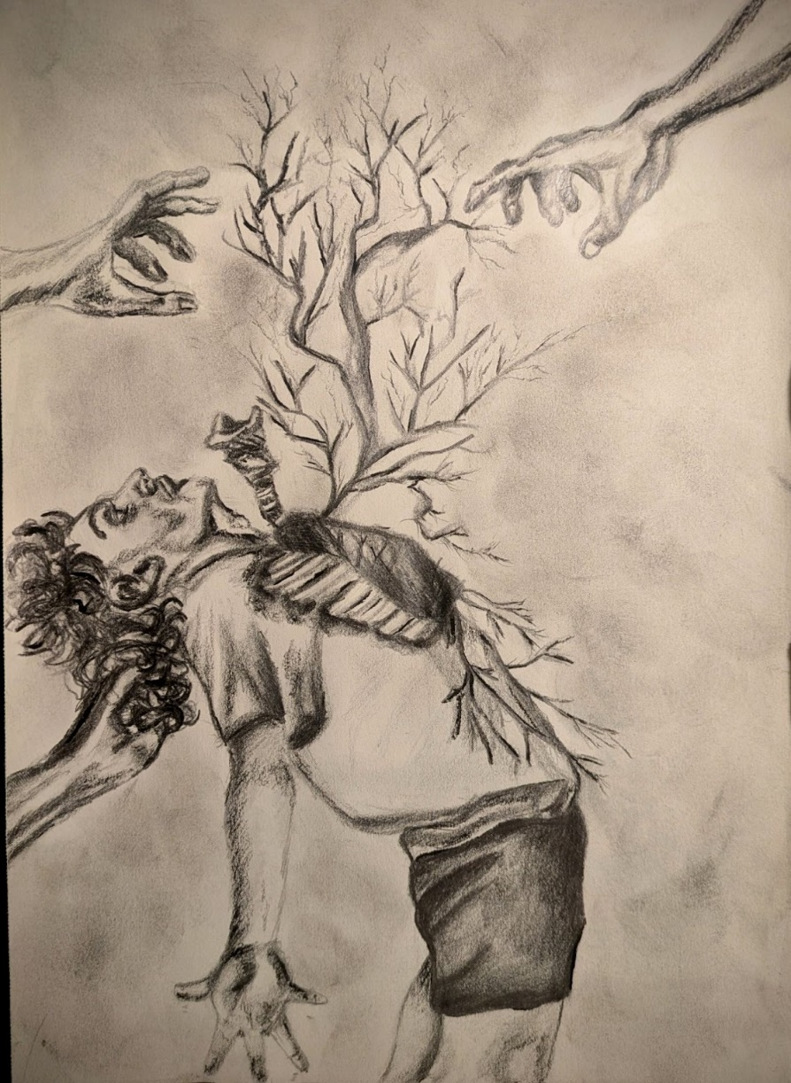

Elias Johnson

Mr. Benson’s Latex Skin

In a suburban neighborhood, right down the street, in the furthest away cul-de-sac, lives a man I think is neat.

His name is Mr. Benson, the friendliest guy around. He’s so funny and so sweet, but the strangest guy in town.

Mr. Benson has a smile that others may find scary. It's really wide, with many wrinkles, and it makes people feel very wary.

Mr. Benson has a hump on the very top of his back. His lanky body hunches over, giant feet getting caught on every crack.

Mr. Benson’s hair is thin and missing from the top. His voice is so scratchy and his growing fingernails never stop.

My mom says to stay away. That Mr. Benson is a creep. That when he smiles it scares her badly, so much that she can’t sleep.

I tell her he can’t help it, that Mr. Benson’s really nice. He was just born with Latex skin, which makes it really hard to live his life.

She says that isn’t it. It’s not his smile that is weird. That there is something deeper within him that fills her up with fear.

She says she can’t name it, but it's at the tip of her tongue. Mr. Benson isn’t who he says he is, and it’d be better if I run.

But I don’t listen to my mother, because she doesn’t get him like I do. She hasn’t spent time getting to know him, to ever hear him through.

Mr. Benson is so funny. He always makes us laugh. He shows us all his memories in his book of photographs.

Me and the other kids wonder what Mr. Benson’s life was like. Before he had his latex skin. Before he lost his wife.

He said he was really happy, before that horrible night came. When the monsters took his wife, and almost did him the same.

He said that they were ugly, 8 feet tall, with dirty teeth. That they came in through the windows, with blood boiling from beneath.

Mr. Benson said he was scared, that he could only run and hide. He said he wished he could have saved her, but it was destined that she died.

We asked him what he meant. What was the destiny of his wife? Why did she have to suffer? Why did she have to give her life?

Mr. Benson ignored our questions. He said that’s just the way things go. When it's your time to leave, they’ll make you believe, and they’ll show up to let you know.

We ask him who they are. Was it the monsters he spoke about? Did they determine everything? Should they be the ones to whom we’re devout?

Mr. Benson smiles wider, bigger than ever before. He says he wants to show us something, behind his secret door.

Mr. Benson stands up and walks towards the door. He puts a key in the hole and turns it slowly but sure.

Inside the room, it's dark and smells bad. Like dust and old books, and something foul and so sad.

Mr. Benson flicks on the light, and there are pictures upon pictures, on the walls and on the floor, surrounded by empty bottles of liquor.

In these frames there are creatures that I’ve never seen before. Some standing on hind legs, and some crawling on all fours.

Mr. Benson looks at me, and starts to rip off his skin. All that's underneath is black, and decrepit, and grim.

He peels his suit down, all the way to his feet, nothing but dark black could be seen underneath.

And as he comes closer, he looks familiar to me. Like the monsters from the pictures, no longer crawling on his knees.

He schlumps his way over, guttural growls come from his throat. His head begins to crown, horns forming like a goat.

His teeth are matted in crusted brown plaque, eyes sunken and bulged, fingernails ripped and cracked.

Closer and closer, his beast tries to test, sizing me up, and bearing his chest.

When he bends down to me, and looks me in my eyes, I realize my mom was right. Mr. Benson is not a nice guy.

Ashley Toms

Ghost Dancer

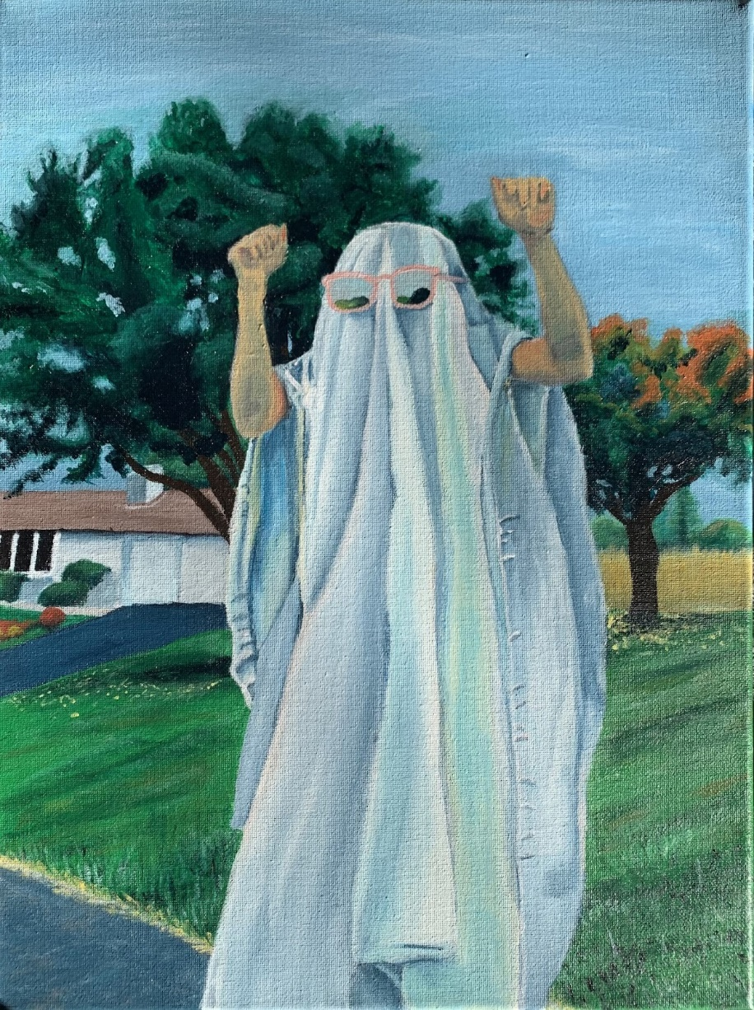

Lauren Pool
I don’t know a thing

I don’t know a thing,
what day is it
the sun doesn’t know,
I keep wandering.

My back hurts
I’m tired,
but I keep smiling
I’m a sunflower.

I don’t know how to cry
no one ever taught me,
I don't know much at all,
Is that a problem?

“I want to be like you,”
my sister said once.
“No, baby girl,
this flower is too fragile."

I don’t know
how to say I love you,
so I hide myself
in borrowed poems.

Behind a
white buttoned
shirt
my petals are falling.
Carmela Caracotche

Comes to Shove
I don’t know when I started to hate him. For all I know it could’ve been just a week or even a month earlier. It could’ve been today even. No, no, probably not today. There was something about Seth that never sat right with me, but no one seemed to notice it. If they had then they were certainly better trained at hiding it than I, not that he ever seemed to notice my scowling. Every morning Mom would remind me to “be kind to him, honey,” but I didn’t think it was worth it.
Could it have been the school bus? I remember its constant rumbling, the stained leather seats… Oh! And the idle chatter of other students. Unfortunately, that includes his voice as well, a single discordant note standing out amongst a pleasant harmony. It wasn’t a shrill or particularly displeasing sound on its own, but it was that way he spoke that got me. There was always that awkward silence that broke out as he barged into someone’s conversation and that giddy smile that never seemed to leave his face. Eventually he’d find his way back to me, somehow sensing that I was finally nearing a state of relaxation. It’s bad enough he went to the same school as me, but he also lived in my neighborhood, which in the eyes of my peers was enough to make him my responsibility.
Right, and then there was that way he’d crash into the seat next to me while calling out that skull piercing “Hey Tobes!” which always seemed to start his conversations in the afternoon. “C’mon Tobes, you gotta let me borrow it—just one afternoon, I promise!” He said, tapping me as he did when he desperately wanted something. The smell of corn chips hounded my nostrils from his breath.
An oh so common sigh left my mouth. “No Seth. I’m not letting you borrow my drone.” I don’t even bother reminding him to call me by my proper name, Tobias. I knew he would forget again for the umpteenth time, relying once more on that painstakingly crafted nickname. When I finally swatted his hand away, a hearty chuckle would blare over the bus’s rumble, and he’d do it again. Not again…
When Seth and I finally got off the bus, he’d tap me one last time before strolling down the road towards home. Knowing he’d stop if I waited, I proceeded to walk near him. The bus’s rumble grew quiet behind us which unfortunately left me with his prattling. He kept going on about the drone and what fun it would be to see the world from new angles while completely ignoring the glimmering pond and soft spring breeze that brushed by us.
“I’m just saying Tobes,“ he tapped me again, “Great things can happen with just a tiny action. We could find untold treasures, unspeakable scenes, or something amazing!” You just need a little push.” He prodded me now, almost making me lose my balance. By now my veins were burning, and my body was rigid. And he was still going on. I wasn’t even walking with him anymore, all I could see was his back---
My blood ran cold. My hands, clenched into a fist now, began to unravel with my haggard breath. Something about his back to me made me stop. My heart was pounding in my chest, threatening to explode out of my chest and slam into him.
Slam. Him. My arms started pulling at me, begging me to act. I didn’t even know what I wanted. An accidental trip, a playful shove, just one little tap. He’s always tapping me, so just this once I’d tap him back for all those times over the past few years. Sure, there’s some interest, but it’ll get paid back. He just needs a little push.
I stood there, frozen, while the bus rolled down the road past me and him. He’d look back at me, surprised that I stopped walking, and wave at me to catch up. I finally exhaled. I didn’t even notice I was holding my breath. I’d glance at a small blackbird on a branch nearby. It only stared at us, as if confused by the scene that played out before it. With a smirk creeping onto my face, I stepped towards Seth.
When I’d get home that afternoon, I’d find Mom carrying the vacuum upstairs. She would ask me how things were with Seth. “Not good, but I think they’re going to be getting better,” I’d say. She’d give me a satisfied smile and a small hug before she went back to her vacuuming. Yup, I could tell. Things were about to be a whole lot better.

Shawn McGuigan

My Friend Death

There’s a certain silence that comes with the dead.
A sense of dread,
That fills your head,
And plagues your dreams with nightmares instead.

I know Death like a close friend.
A boney hand that tries to mend
The constant demand
Of prayers and screams with no end.

On nights when the moon is blocked by a cloud,
I remember the faces of the dead and whisper their names aloud,
Begging that they are proud
Of the girl that chooses to disappear in the crowd.

I hold my breath as I pass their headstones.
A chill runs through my bones
At the thought of the groans
Of the souls of the dead trapped beneath these unknowns.

Sometimes I wish for a visit from Death.
A snatching of a single breath,
The loss of life’s wealth
That sends my soul into that eternal depth.

And yet, despite my hopes, I’m left here
To live out this tiring year
With not a single fear
Of when Death will once more be near.
Alex Heckman

Have You Seen…

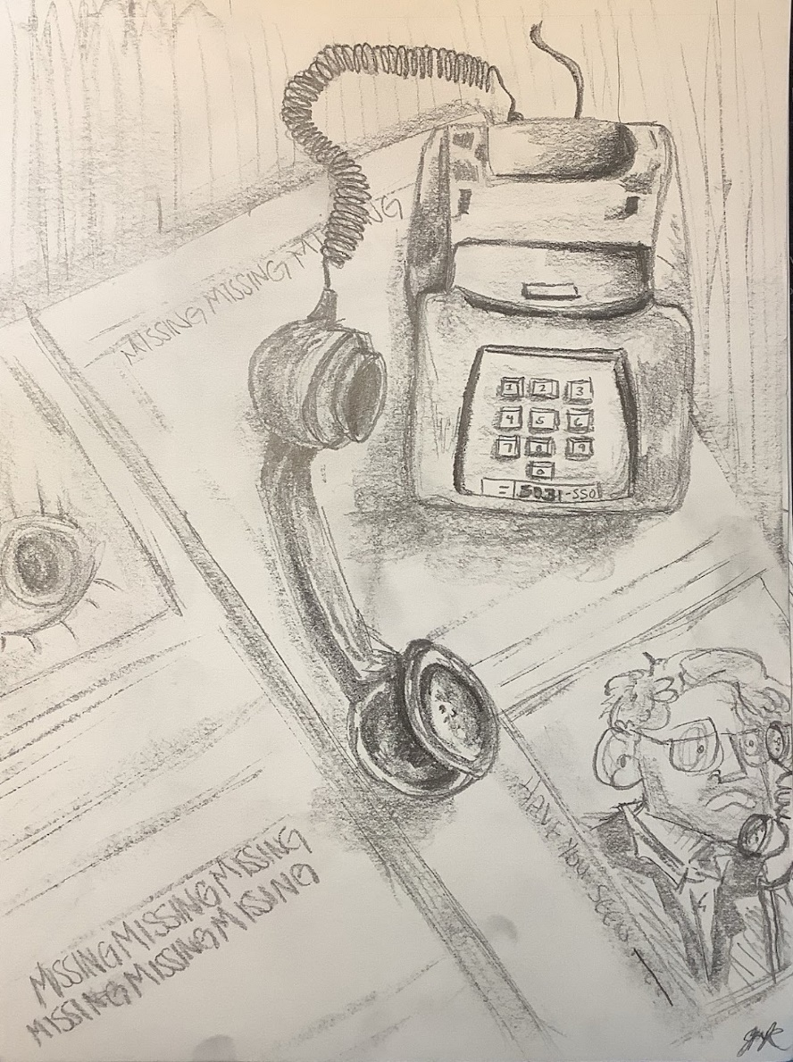

Jenny Russell

Breaking the Cycle

When I die, bury me by the pond
Somewhere serene with little noise
Not because I wish to be at peace
But so, I do not get too overwhelmed
By the calamity of the harp
Of what could have been done differently

When I die, don’t bring me flowers
I can’t have another reason to cling to validation
I need to quit this desperation cold turkey
Let me decide if my own life was appreciated enough
Besides, there needs to be room on my tomb
For what I was holding that didn’t cradle me back

Call it muscle memory
The way I will grow where the water is murky
I am the same in both life & death
But do me a favor, When I die
Sever my roots before they seep into the landfill above
For I could never do it on my own

When I die, I will be reborn
Just give it some time
My seeds will sprout again, alongside the water
I will take the garbage I left upon my grave
& turn it into compost for my garden
By the pond, I will drown out the unrestful strings
With the sound of bees caring for the very flowers I have birthed
Jenna Tecchio

Closing Time

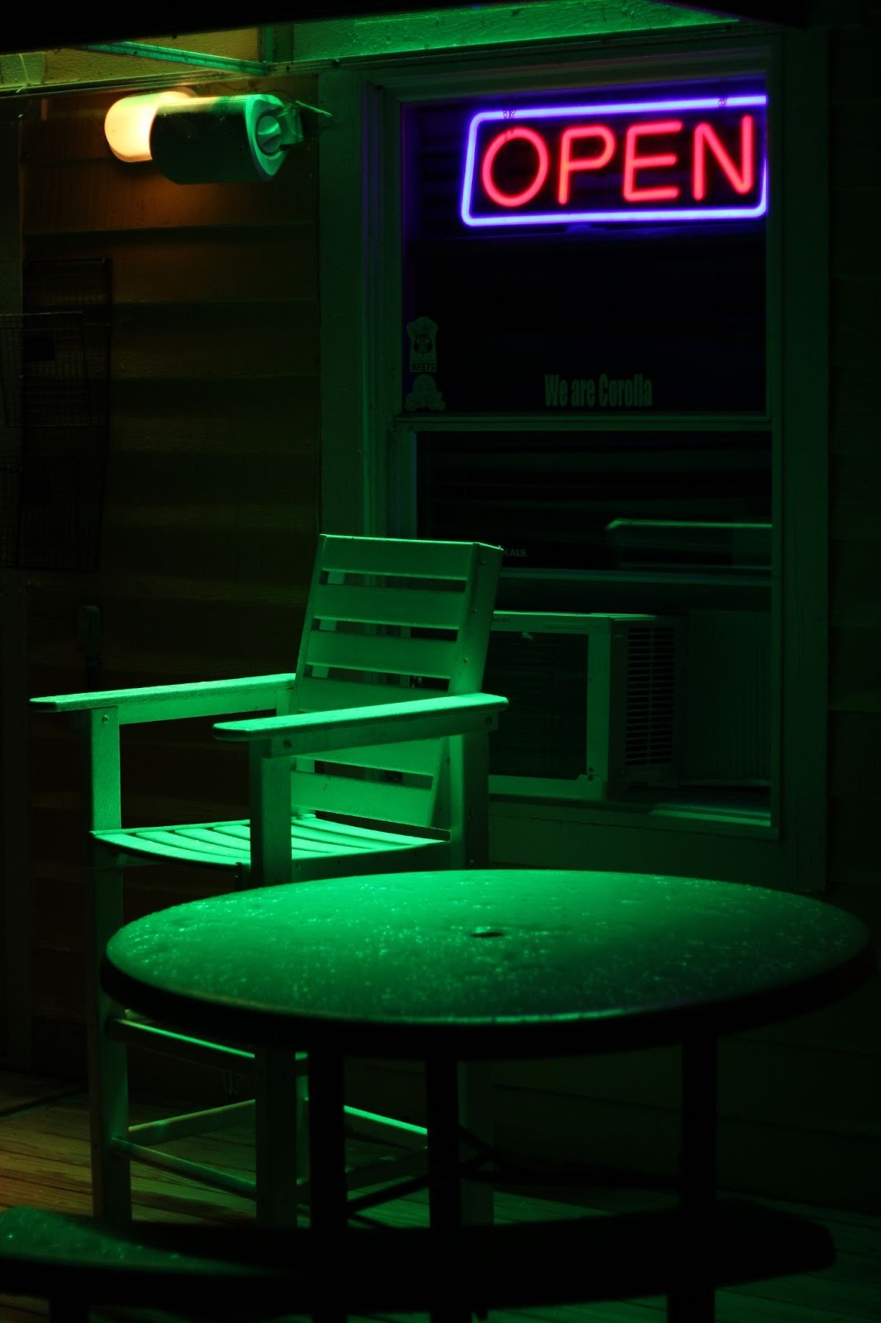

Madison Sharp
What is the Opposite of Speed
The words won’t come to me.
The train has stopped on the tracks.
An unstoppable force,
usually forceful and turbo,
now stuck,

in a paper jam.

The wheels are glued to the rails.
The engine blackens with smoked steam.
Oil leaks onto gravel below the undercarriage,
leaving puddles of murk to flood the depot.

And the train doors are bolted shut.
The words become locked in place.
No way to escape.
But I think they did this to themselves.

The words never wanted to leave in the first place.

Ashley Toms
A History of the End of the World
The following is a shortened excerpt from my novel, “The History of the End of the World” , a satirical piece on human nature and technological progress.

Chapter 1
A pigeon, of all things, has been blamed for the end of the world. Not just any pigeon, but a very specific pigeon with a blue stripe on its neck and eyes that never focused unless there was a bagel in the near vicinity. This infamous pigeon has been referred to as Gary, and your guess is as good as mine as to why.
You see, there was a man named Ali Jones who had fallen on hard times. His company, CureCancer, had failed to cure cancer, which was not ideal for a company with that name. As a result, they made cuts. Ali Jones had been demoted. If student loans and type one diabetes were not problems for Ali, the world might not have ended. Arguably, the end of the world was due to the lack of free healthcare and education in America, but since addressing that might make people angry, we’ll stick to blaming the pigeon.
Ali was approached by KillCancer—not to be confused with CillCancer, whose mission
to eliminate anyone born between June 21st and July 22nd had been disturbingly successfulKillCancer was CureCancer's rival, and they wanted the latest cure. The money was enough to cover Ali’s student loans and his medical bills, so, naturally, he accepted.
The disaster happened as Ali stole the papers. He was by a window, printing off the
records as the street below filled with honking cars and hurrying people. One of these cars was particularly upset—if an inanimate object can be upset—and went around a garbage truck just as the garbage truck turned down an alley. The car spun onto the pavement, the only casualty being a pigeon mid-flight, who was launched into the air like a feathery missile. Gary, of course.
This pigeon was propelled directly at the window where Ali was, shattering the glass and somehow surviving because, if we’re being honest, pigeons are built differently. Ali, as any person would do, screamed and scrambled away from the mess of glass and feathers. Amid the chaos, one page of the report got sucked out the window, and as Ali grabbed the papers, he was unaware of the missing page.
The page floated down toward the car crash, which exploded along with the paper, the words “DO NOT MAKE AGAIN, DANGEROUS!!!” disappearing in flames. (It should be noted that writing warnings in all caps doesn’t make them any more effective if no one actually reads them.)
Needless to say, disaster ensued. Gary shook himself free from the mess, cooed in triumph (or confusion, it’s hard to say) and flew away. Ali delivered the report, and the world began to end.
Chapter 2
The cure was developed and, miraculously, it killed every cancerous cell, and was quickly
distributed. Cancer patients were healed, CureCancers stock failed, and everyone was happy.
For a week.
The first person cured died. Then the second. Then the third. In fact, the only people not dying were the ones who hadn’t been cured, which would have been ironic if it weren’t so horrifying.
It turned out that while the cure killed all cancerous cells, it then proceeded to kill all
other cells. This would have been horrible enough, but then the doctor that had given the cure to the first person died. Then the husband of the second person cured died, then the son of the third person cured died, everyone was dying, and it all started to feel like a very bad pyramid scheme.
Alabama became the designated place for all dead bodies. Quarantine was mandated.
Still, the cure managed to spread, and before long, all of the Americas were suffering. China was hit next, and soon most of Asia. At some point, France had been affected, and by the time the cure hit Australia, most of Europe was dead. (It remains unclear whether Antarctica was impacted, as penguins are notoriously difficult to interview. Presumably, the penguins were too busy arguing over fish to notice.)
Needless to say, six months after the first cure, there were more blue whales than living people. (There was quite the celebration by the whales when they learned this. Since then the population has doubled.)

Chapter 3
Just because the world ends for most people does not mean that it ends for everyone. It did not, for example, end for Adam Walker. In fact, Adam Walker had no idea the world had ended.
It was Wednesday, and on Wednesdays, Adam went to town. That was how it was and how it always had been. If the Queen herself had arrived and asked Adam to reschedule, he would have offered her tea and politely shown her the door.
Adam woke up on that Wednesday, put on his dressing gown and shuffled downstairs to make tea. Adam was very proud of his lifestyle and had told anyone who asked (which had only been two people, one of them his mother) that he wanted to be able to support himself entirely, so even if the world ended, he would be fine. Adam had never thought the world would actually End.
That would be absurd.
It was a little past nine when Adam got on his bike- not in his dressing gown, but a button down and trousers- and rode into town. It struck him, about five minutes into the ride, that he had seen no cars or people. This was not entirely uncommon, as the Sussex downs could be very empty, filled with farmland, trees, and the occasional cliff. Not many people found a need to
come there.
However, Adam could usually count on seeing the post van and at least one farmer grumbling in an old truck that looked as though it ran on stubbornness and prayers.
By the time Adam got into town, he was confused. He had not seen any sign of human
life at all on his ride, and as he pedaled by the town's new JumboMart, his confusion turned to worry.
The automatic doors had been torn up and the inside looked as though there had been a hurricane. Adam stopped his bike and looked about. The question was, who had done this to the store. The streets were empty and very, very silent. When was the last time he had heard a tractor? When was the last spoken to someone? No one had mentioned evacuating the town. Adam was quite sure of it. It seemed that everyone and simply vanished.
“Well that’s not ideal.” Adam muttered out loud.
Understatements were one of Adam’s many talents, alongside making excellent jam and completely misunderstanding social cues.
A gust of wind blew and a plastic bag flew across the entrance of the JumboMart. Adam sighed, propped up his bike and chased after the piece of trash. Thankfully the bag got trapped against the shopping carts and Adam shoved it into the nearest recycling bin. Perhaps, he thought, everyone is simply inside.
Perhaps there had been a weather warning of sorts or a government demand. The government was sometimes like that.
It was a somewhat reasonable thought, so Adam got back on his bike and went to visit his friend Will. Will was arguably the only friend Adam had, and he lived on the other side of town, but it only took Adam a few minutes to get there.
Will's house was dark, which was surprising given it was nearly ten in the morning and Will was often awake at six. It was possible that Will had gone out, but his car was in the drive.
Adam hopped from his bike and knocked on the door. He looked at the neighboring houses, each as silent as the next. Nervously, Adam knocked again.
“Will!” He called, “Will, it’s Adam!”
There was no response and Adam muttered a curse. He peered through the window. The house looked ordinary, coats all hung up in rainbow order, newspapers stacked in a corner. Adam squinted at the newspaper. It was from a week ago.
“Oh dear,” Adam murmured, pacing, “Oh dear something isn’t right.” Adam tried the door, which opened without so much as a groan. Will always locked his House.
“Oh dear oh-dear-oh-dear.” Adam whispered, flicking on the light switch. No light came.
Adam flicked it down, then up, then up down- “Will?” He called, his voice high. “Will, please
come out.”
There was a noise from the other room. Adam relaxed.
“That wasn’t very funny.” He said.
It was Will's cat.
The cat stared at him with all the indifference of a creature that had no concept of disaster, only empty food bowls.
That was when Adam knew that the world had ended. Will, under no circumstances would leave his cat. Adam was forced to conclude that everyone had simply vanished and that he would never see them again.
Adam took the cat and rode back home.

Hannah Campbell

Eggs in a Basket

I can hear the birds in the window, a subtle chirp
with the sunlight shining in
I hum a quiet song

I slip my favorite pan onto the stove, a swift turn
to the left for bread
I cut a small circle into each slice

I grab stick butter and a carton of eggs, a slight step
up to the stove for heat
I butter the large surface

I place each piece of bread softly, a light crack
of each egg into each circle
I let them cook

I inhale the warmth of buttered bread, a small pop
from the bubbles rising

I flip

I move my hearty breakfast to my plate, a wide smile
reaches from ear to ear
And I eat.

Eloise Brewsy

Exit Routes
Second Place | Dziennik-Russell Prize of Excellence

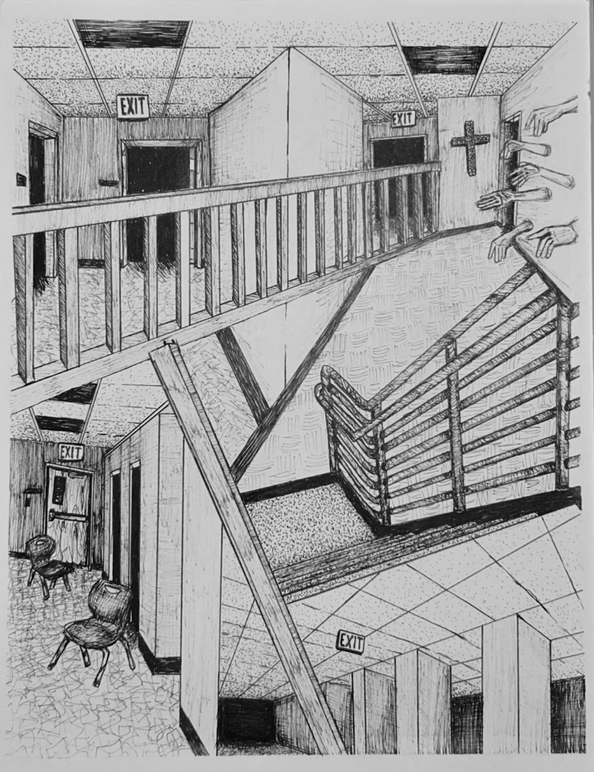

Eleanor George

New York city in December
last year was different
the wind was low and languid

the right kind
I wasn’t even sure why
no, that’s not true. I knew why

love letters should always be
longer than 500 words,
he says

we wander
in between little streets
counting yellow cabs

sometimes people think
it would be irresponsible
to love

It is convenient
nobody has much time
(we do have)

it’s December again,
the right kind,
a love letter, just us

Carmela Caracotche

Butts IX

Left Cheek: Right Cheek:
She’s aerodynamic An eloquent mass
of booty
Crashin into me Booty
Makin me question Booty
Where I am Rockin 'Everywhere.

Swirlin and whirlin Earthquake.
Makin me dizzy Booty Cheeks
Jeans and boots Swivel in the air.

Nasty. Stinky.

Anonymous
Bar

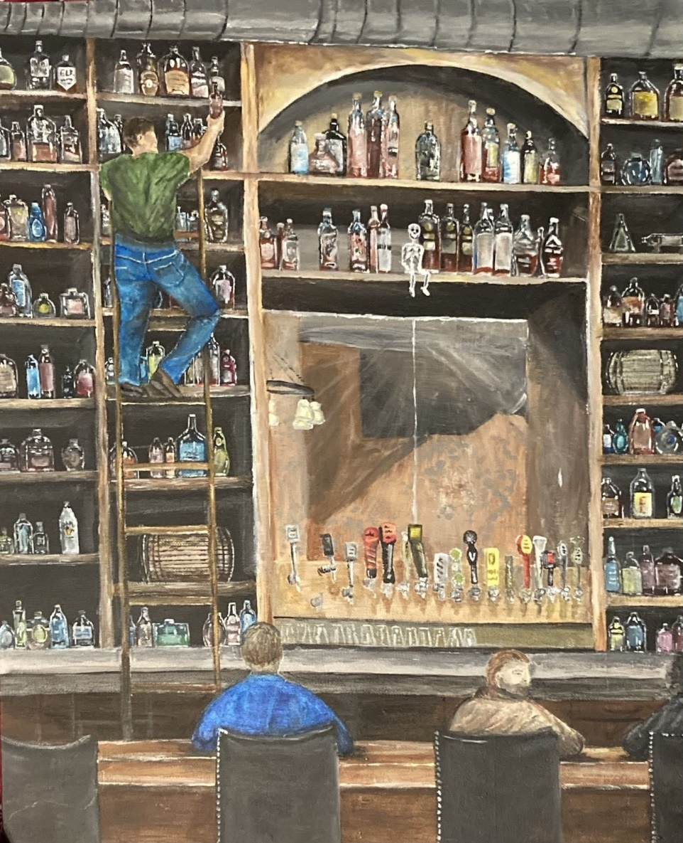

Elizabeth Lonkart

A Man’s Best Friend
Nothing’s the same and I’m white-knuckled
You say the door is open—have I overstayed my welcome?
C l i n g i n g
Because I know you
I can see it in your eyes: an Old Yeller
The deadbolt clinks
& I’m
S i n k i n g
If you wanted me to go, why is the porch light still on ?
You are a language that only I can speak—will it ever end ?
Part of me longs for peace
The other is yearning
To know no such thing if it comes with your absence,
But I can’t sit by the window any longer
Or be the dog waiting by the door
For you to come home & choose me
again.
Not when I have the whole world ahead
Not when you chose to leave everything behind
Not when you’re uncertain about me.
& so, I’ll roam—even if it means
That I have to stop my tail from w a g g i n g.

Jenna Tecchio

“Lines”
“Motherhood is natural. Motherhood is the place of a woman.”

It’s easy to say that as a man speaking from the pulpit with the approval of a God that they paint to be fair. This God is molded to be unfair for the sake of man’s control. It’s easy for him when the majority of the people settled into their pews are older, young and impressionable, or young parents who already subscribed to the ideology.

“Motherhood changes you. It all makes sense when your baby is in your arms.”
My mother went through the pain of postpartum depression. My dad said she was never the same after my older sister was born. The lack of proper mental health care destroyed my own mother. There are times that I wish I got to meet her before all of this shook her foundation.

“Motherhood is your next step. Men want to continue their last name.”

My sister told me every part of her process with great honesty and grace. It was the first time I was close to pregnancy and babies in my nearly two decades on the planet. I can remember how horrible it felt for me to watch all of the people I loved most treat her like the thing inside of her was the only thing that mattered, touching her and making comments that made my skin crawl. I only wanted to acknowledge the most influential woman in my life like I always did.

“Motherhood will make you feel alive. Motherhood is tender.”

I fear my own body. A recurring living nightmare that haunts me is one where I am tethered to my bed, riddled with post-partum depression. In the night, after hundreds of tears are shed over my ruined body, I can hear a little girl calling for me from far away.
“Mama… Mama…”

My mom and dad wondered why I decided to become sterile, why I sought out an OB/GYN in Harrisburg instead of near home. I was scared. I was afraid. I never wanted to know man, know pain, after how much I had grown into myself. I deserved me. It was the best gift I could ever give to myself. Many were supportive, others did not understand, others now wonder why I would go through with it now that I understand that I am a lesbian.

“What about your husband? What if he wants a child?”

I am not put on Earth to serve a man, to be his property, his stock. It doesn’t make me selfish to want a life that I believe to be best for myself. You wouldn’t ask the same of a man who receives his sterilization. You might even call him responsible, when you call me a monster. Should I believe that my body is being devoured by a nightmare just to further embellish someone else’s life? If that is what a good life is, I don’t want it.

“What about your future? What if you change your mind?”

My future doesn’t have to include something that isn’t a requirement for a fulfilling life. I have no regrets over the decisions I have made for myself. I’m the happiest I have ever been, and have grown more than I ever have in my life. Few slow down enough to truly appreciate that bliss, and fewer onlookers can fully observe such a shift. Not only that, but most people who have made this life decision feel the same. Would you dare torture the countable over their regrets to dismantle the joy of the uncountable?

“How do you feel one year post-procedure? Feeling good?”

“I feel absolutely amazing!”

I will never have to watch more than one line appear on a newly opened test.

Katie Waite
keep digging
back hunched, arms and legs aching
she grips onto a shovel,
forged from her regretted actions and words she wishes she could take back
each apology, each white lie used to cover her tracks
forces her to use that shovel of guilt
“I didn’t mean it”
dig.
“I’m sorry”
dig.
“I just forgot, I have a lot on my mind”
dig.
dig.
dig.
keep digging till you’re in a dark hole that no matter how hard you try to fill
will only keep getting deeper
desperate and bleeding
she stares longingly at the top
where he stands
with disappointment and pain etched onto his face.

Lauren Pool

Blind Date

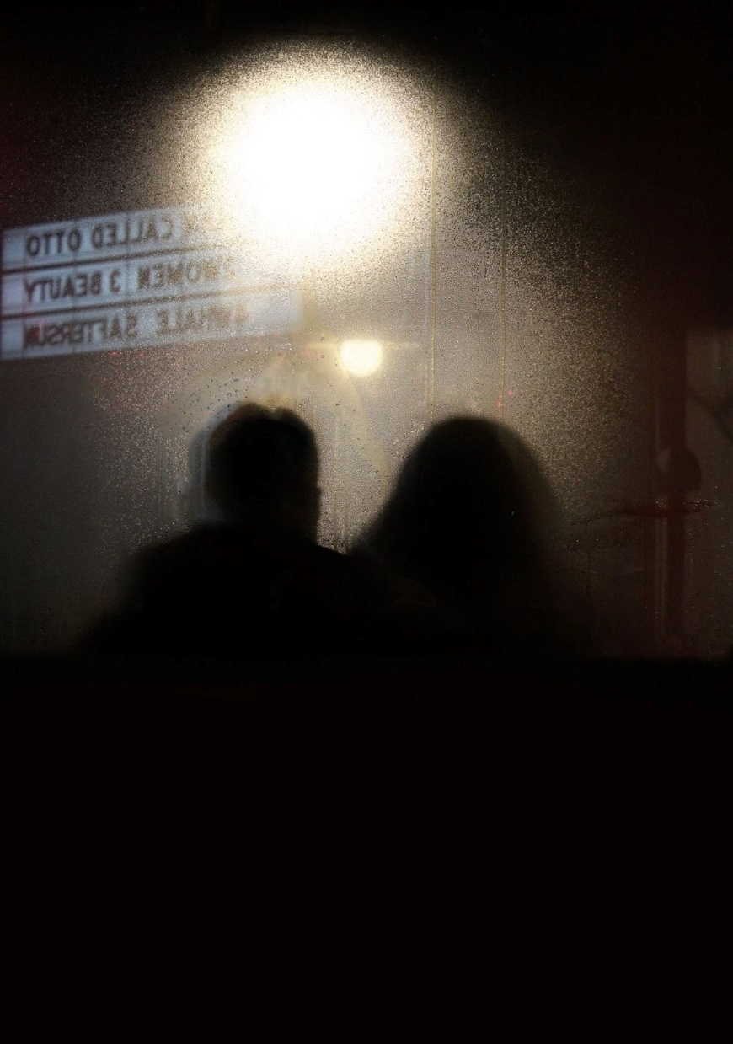

Madison Sharp

this is not a poem
First Place | Dziennik-Russell Prize of Excellence

or art,
nor a song
meant to make you smile
writing that a cloud
said hi to me this morning
it’s not supposed
to change the world
to end wars
to tell how
the old lady in white
stopped in the middle of the street
just to feel the sun
or when
a vaquita de san antonio
followed me all the day
like it had something to say
writing how freezing cold
the wind was on monday
and how the fallen leaves
left us almost crying
this is not a poem,
but if for one minute
just one
you looked up at the sky
and thought
how beautiful it is
then my job is done

Carmela Caracotche

/or

Submit to
The Reflector
Prose | Poetry | Art
Now excepting submissions year-round.
To submit to The Reflector, or for more information, contact The Reflector at reflect@ship.edu

